Project By:

B. Jeevanantham Balakrishnan

AWS 3 Tier Architecture:

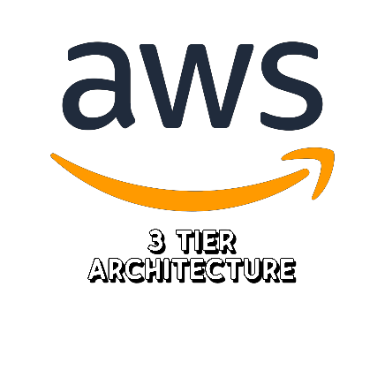

AWS 3-tier architecture is a cloud computing architecture that divides an application into three logical tiers:

• Presentation tier: This tier is responsible for interacting with the end user. It typically consists of web servers that deliver HTML pages, images, and other content to the user's browser.

• Application tier: This tier is responsible for processing business logic and data. It typically consists of application servers that run the application's code and interact with the database.

• Data tier: This tier stores the application's data. It typically consists of a database server that manages the data and provides access to it.

The three tiers are typically separated into different Amazon Web Services (AWS) services. For example, the presentation tier might be hosted on Elastic Load Balancing (ELB) and Amazon EC2 instances, the application tier might be hosted on Amazon EC2 instances, and the data tier might be hosted on Amazon Relational Database Service (RDS).

AWS 3-tier architecture offers a number of benefits, including:

• Scalability: The application can be scaled up or down easily to meet changing demand.

• Availability: The application can be made highly available by deploying the tiers in multiple Availability Zones.

• Security: The tiers can be isolated from each other to improve security.

• Cost-effectiveness: The application can be deployed in a cost-effective way by using the right AWS services.

AWS 3-tier architecture is a popular choice for building scalable, reliable, and secure applications. It is a good choice for a variety of applications, including web applications, mobile applications, and enterprise applications.

Steps involved :

• Download the App tier, Web tier files from the Github Using Gitbash to your computer.

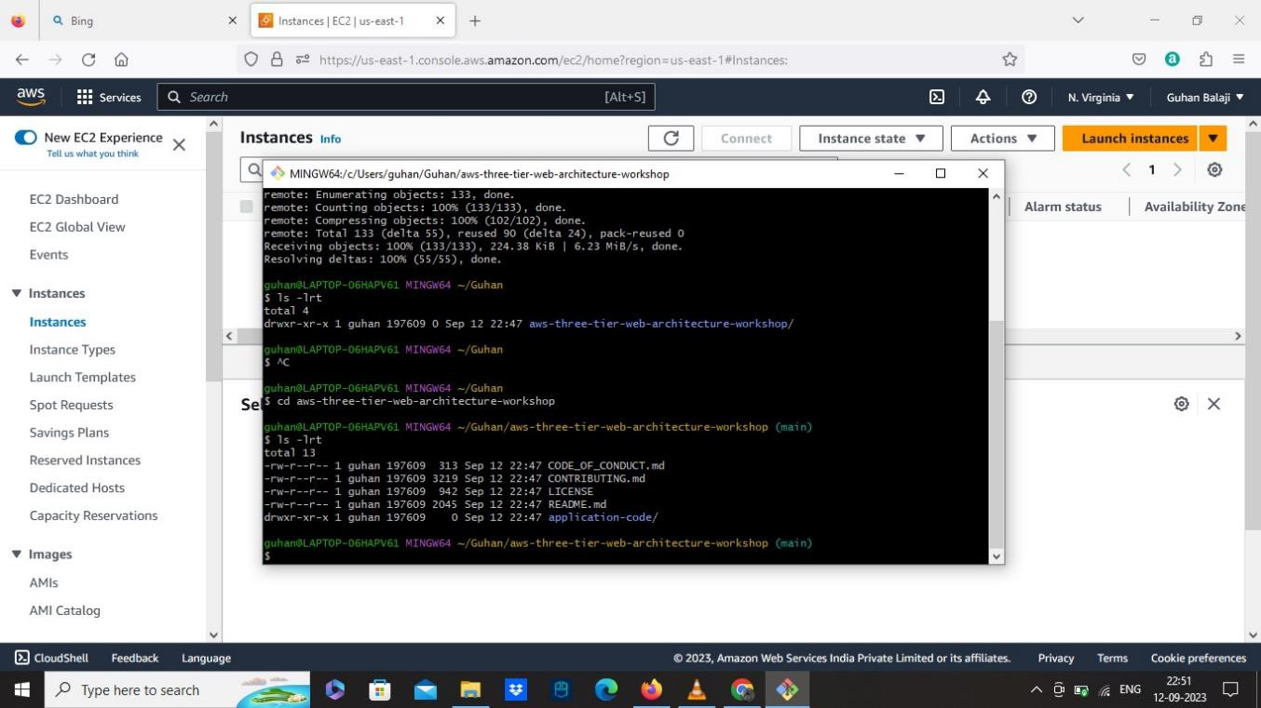

• Create a new S3 bucket in your AWS console.

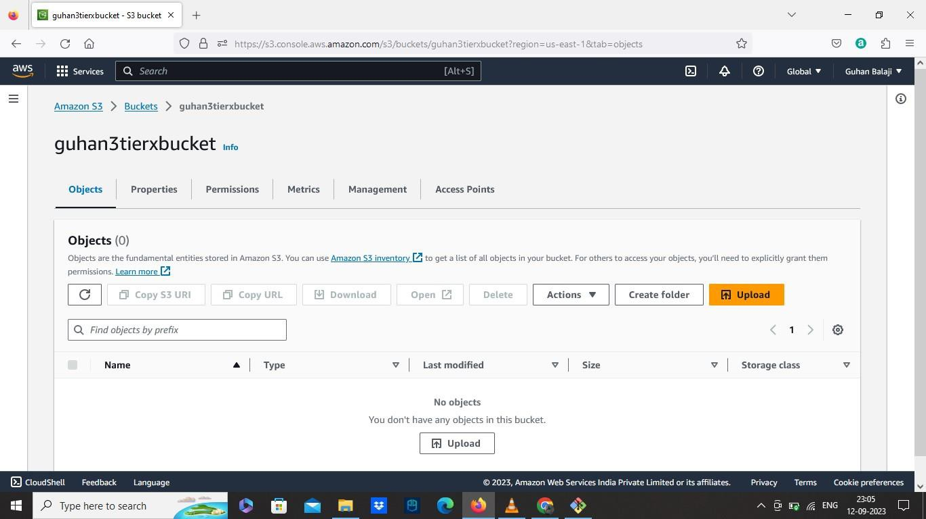

• Create a new IAM role:

• Select AWS services as Trusted entity type.

• Select EC2 for common use case.

• Add permissions to your role AmazonSSMmanagedInstanceCore and

Amazon S3 read only access.

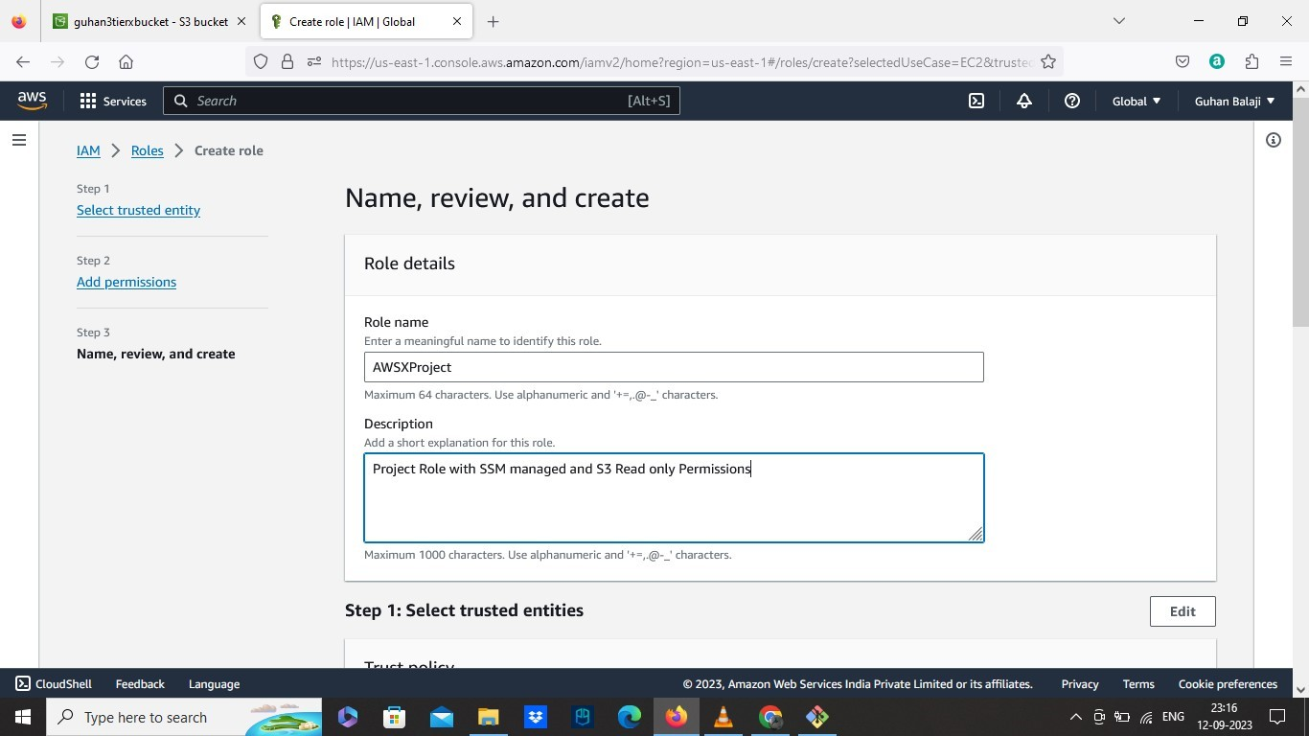

• Create a Custom VPC:

• Select VPC only

• Select IPV4 CIDR manual

• Use 10.0.0.0/16 CIDR block

• No IPV6

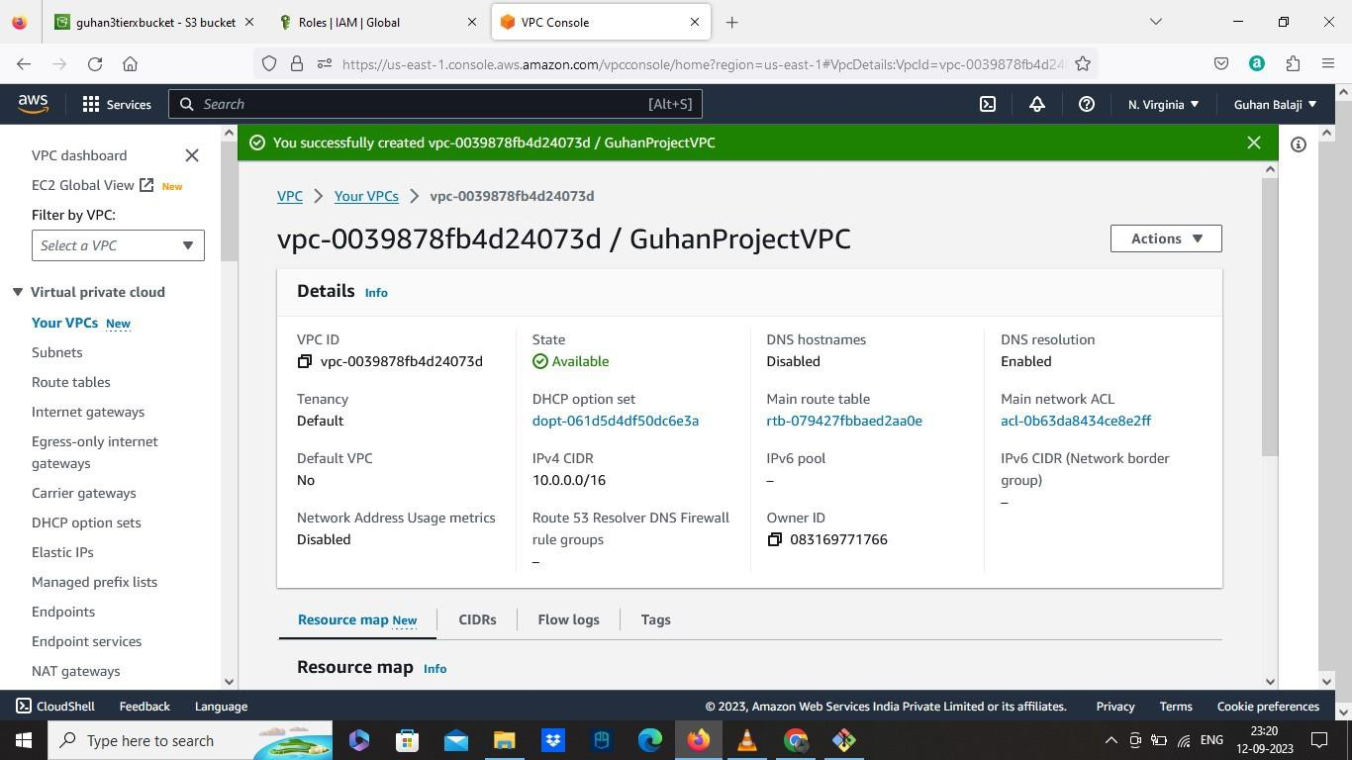

• Create Subnets

Here we need to create 6 subnets in two different regions for each tier.

For WEB TIER: Two Public Subnets

• Subnet 1:

✓ Add our created VPC ID

✓ Name as Public Web Subnet AZ1

✓ Select Availability zone- US east 1A

✓ Select 10.0.0.0/24 as IPV4 CIDR block

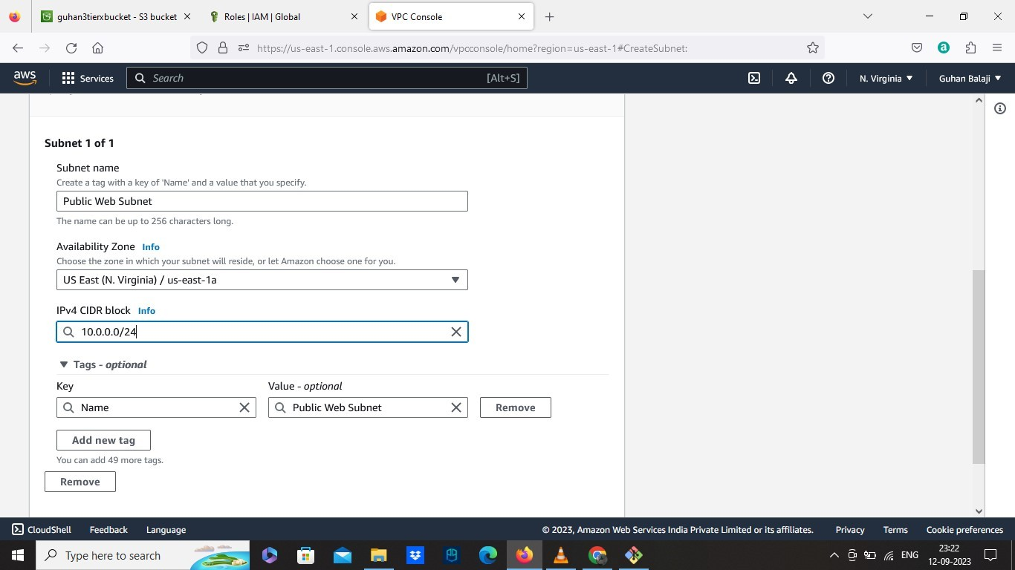

• Subnet 2:

✓ Add our created VPC ID

✓ Name as Public Web Subnet AZ2

✓ Select Availability zone- US east 1B

✓ Select 10.0.1.0/24 as IPV4 CIDR block

For APP TIER: Two Private Subnets

• Subnet 3:

✓ Add our created VPC ID

✓ Name as Private App Subnet AZ1

✓ Select Availability zone- US east 1a.

✓ Select 10.0.2.0/24 as IPV4 CIDR block

• Subnet 4:

✓ Add our created VPC ID

✓ Name as Private App Subnet AZ2

✓ Select Availability zone- US east 1B

✓ Select 10.0.3.0/24 as IPV4 CIDR block

For DB TIER: Two Private Subnets

• Subnet 5:

✓ Add our created VPC ID

✓ Name as Private DB Subnet AZ1

✓ Select Availability zone- US east 1a

✓ Select 10.0.4.0/24 as IPV4 CIDR block

• Subnet 6:

✓ Add our created VPC ID

✓ Name as Private DB Subnet AZ2

✓ Select Availability zone- US east 1b

✓ Select 10.0.5.0/24 as IPV4 CIDR block.

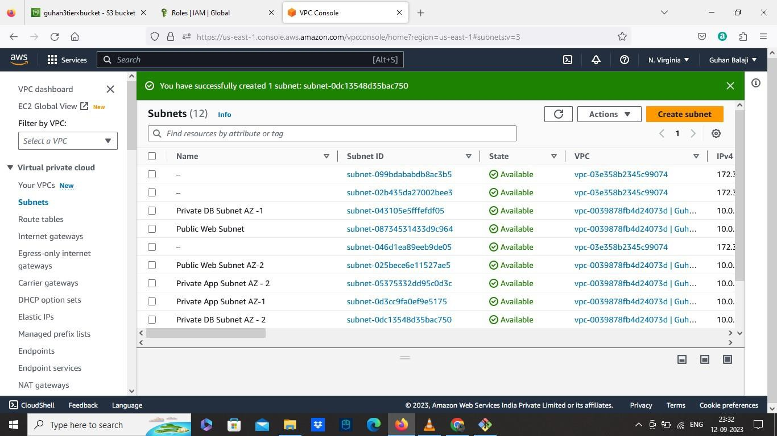

• Create Internet Gateway:

• Attach to our Custom VPC.

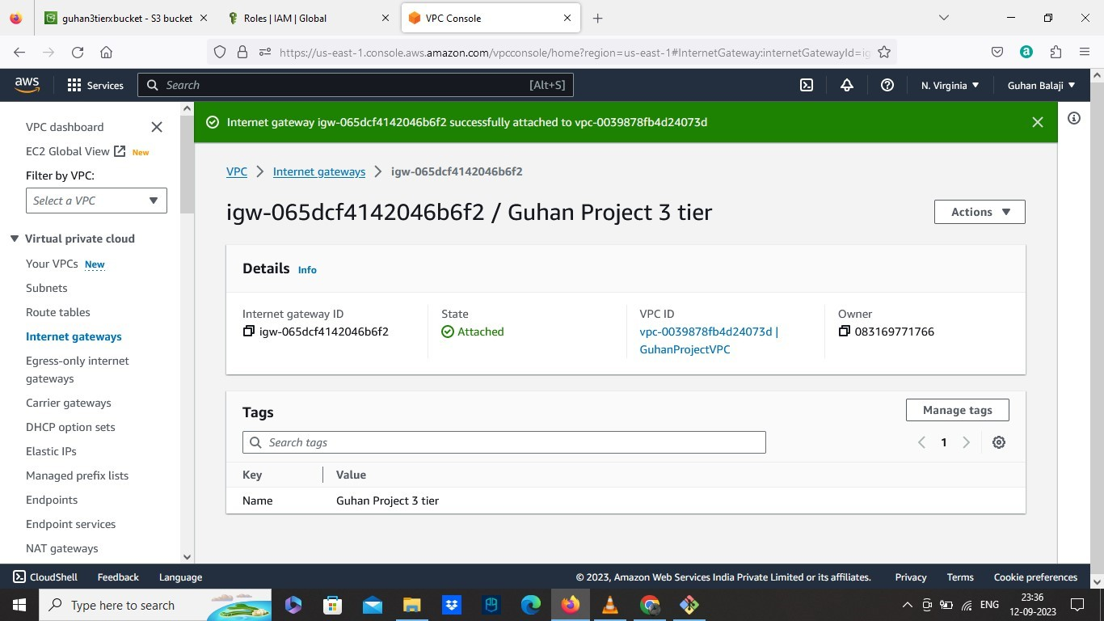

• Create Two NAT Gateways

• One for one availability zone 1a and other for 1b. Allocate Elastic IP for each.

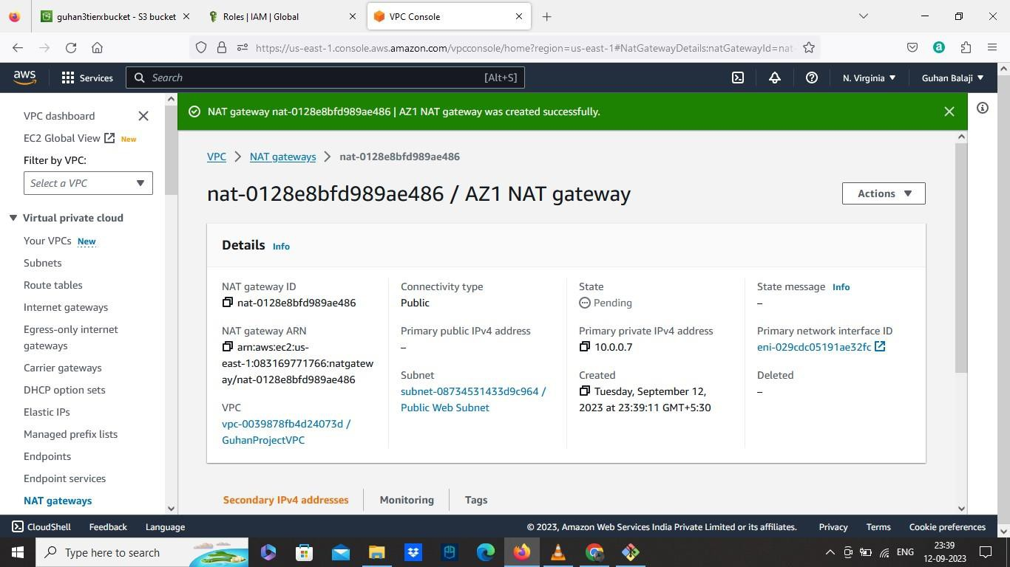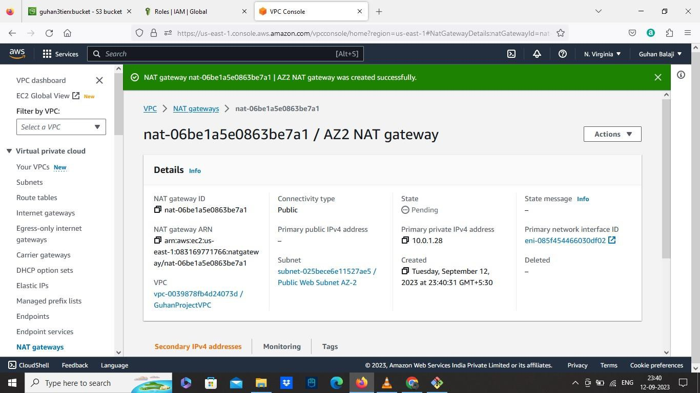

• Create Two Route Table:

• Route Table 1:

✓ Select our VPC.

✓ After created, Go to Edit Routes and add Route destination as

0.0.0.0/0 and select target as Internet Gateway we created.

✓ Then go to subnet association and edit subnet association. Select two Public Subnets AZ1,AZ2.

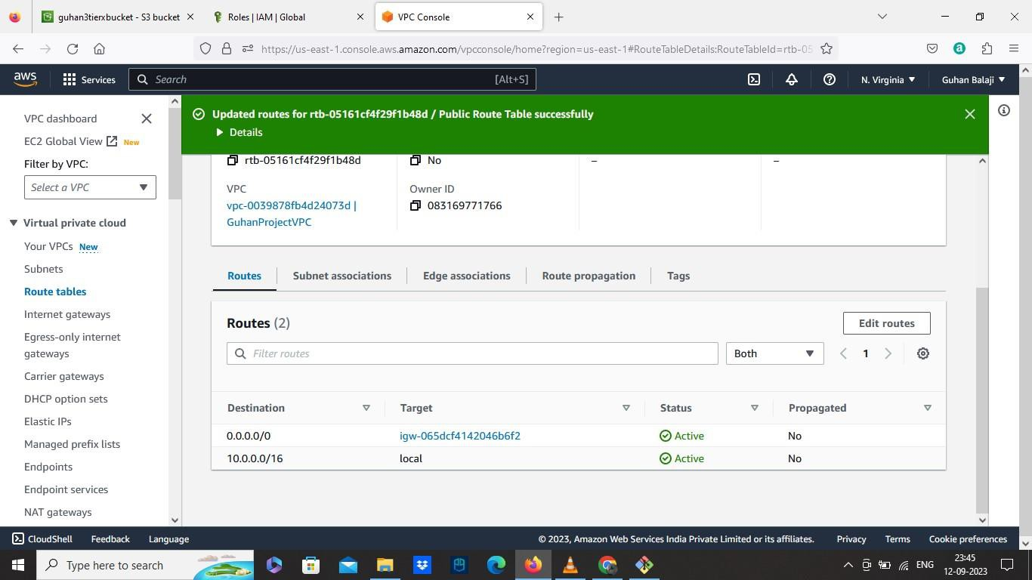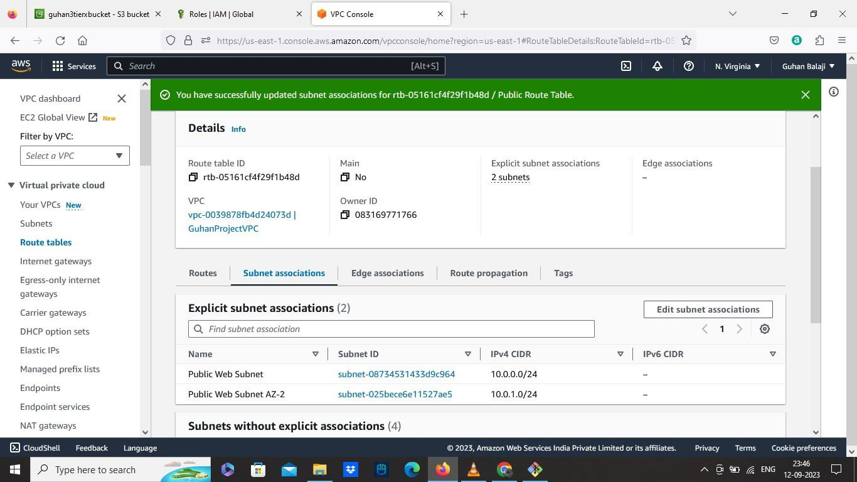

• Route Table 2: ( Private Route Table )

✓ Select our VPC.

✓ Then edit routes, add route destination as 0.0.0.0/0 and Select target as NAT gateway we created.

✓ Go to subnet association and select two Private App Subnets

AZ1,AZ2.

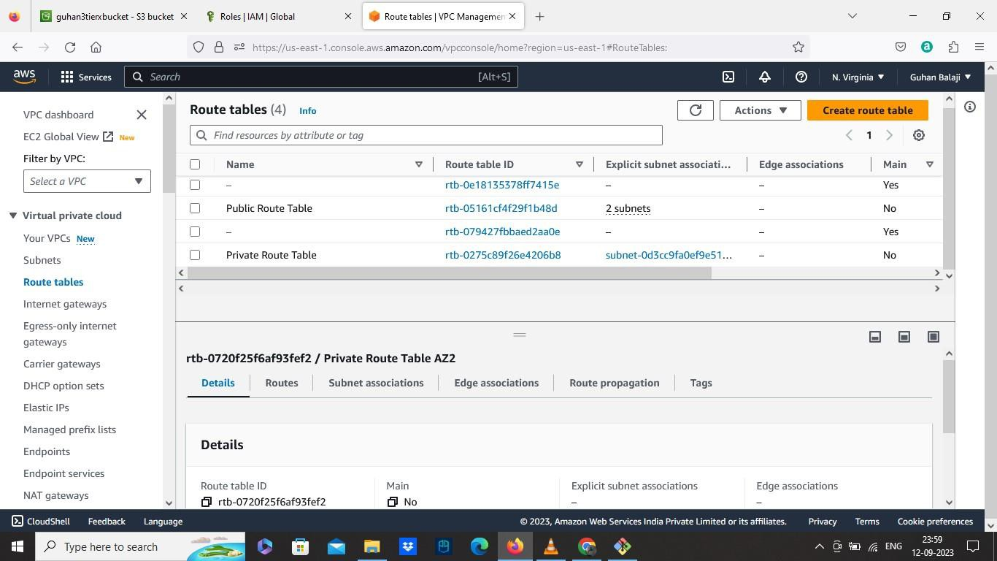

• Create Security Group

Here we need to create 5 security groups which is for Internet Facing ELB, Web tier, ILB, Private Instances,Databases.

• SG 1 ( for Internet facing ELB )

✓ Select our VPC

✓ Add inbound rule1 – Type as HTTP, Source as 0.0.0.0/0 and port range as 80

✓ Add inbound rule 2 – Select Type as custom TCP and select

Anywhere IPV6.

✓ And Create.

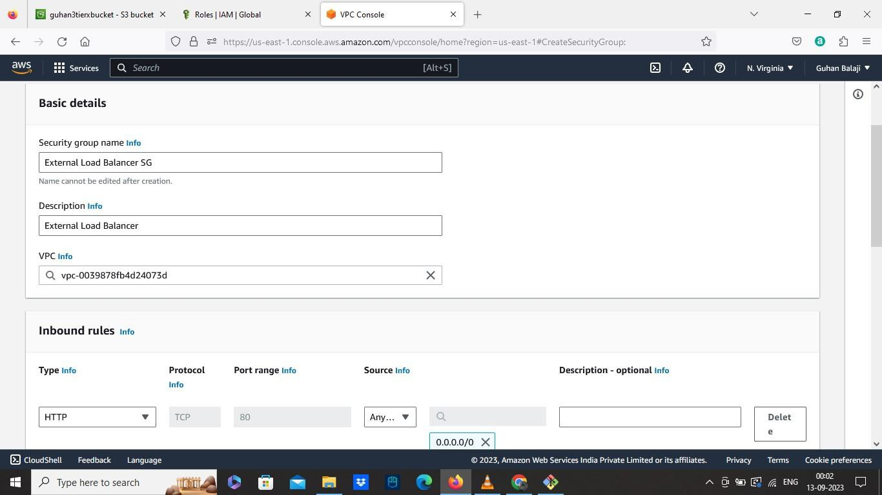

• SG 2 ( For Web Tier )

✓ Select our VPC

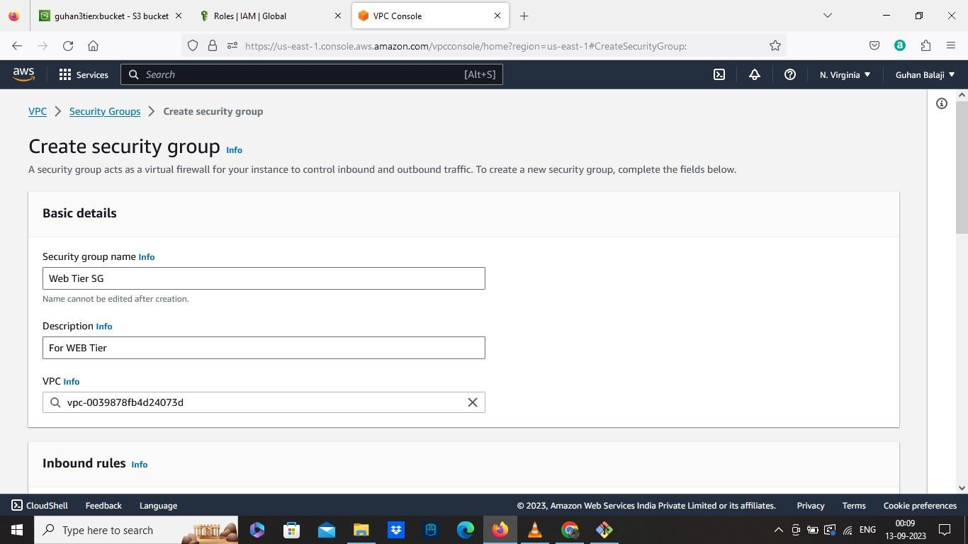

✓ Add Inbound Rule 1 – Select HTTP, source as External LB SG (

previously created SG )

✓ Add inbound rule 2 – Select HTTP, source as MY IP.

• SG3 ( Internal Load Balancer )

✓ Select VPC

✓ Add Inbound Rule 1 – Select HTTP, Source as Web Tier SG

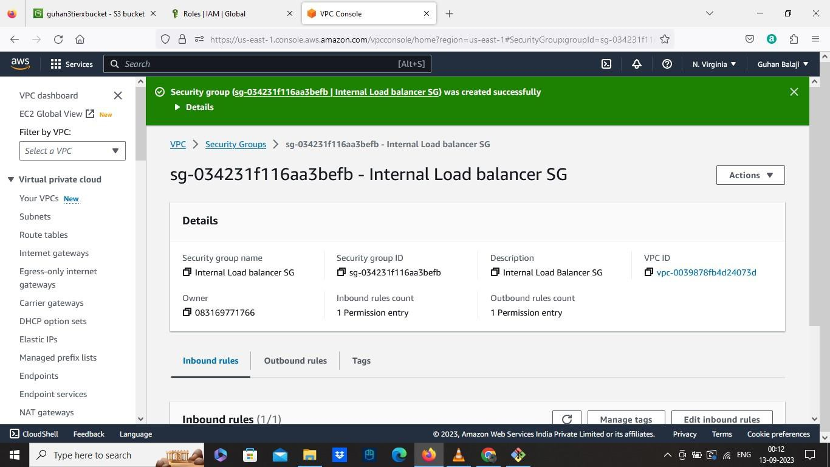

• SG4 ( Private Instances )

✓ Select our VPC

✓ Add inbound rule 1 – Port range – 4000,source as Internal Load

Balancer SG

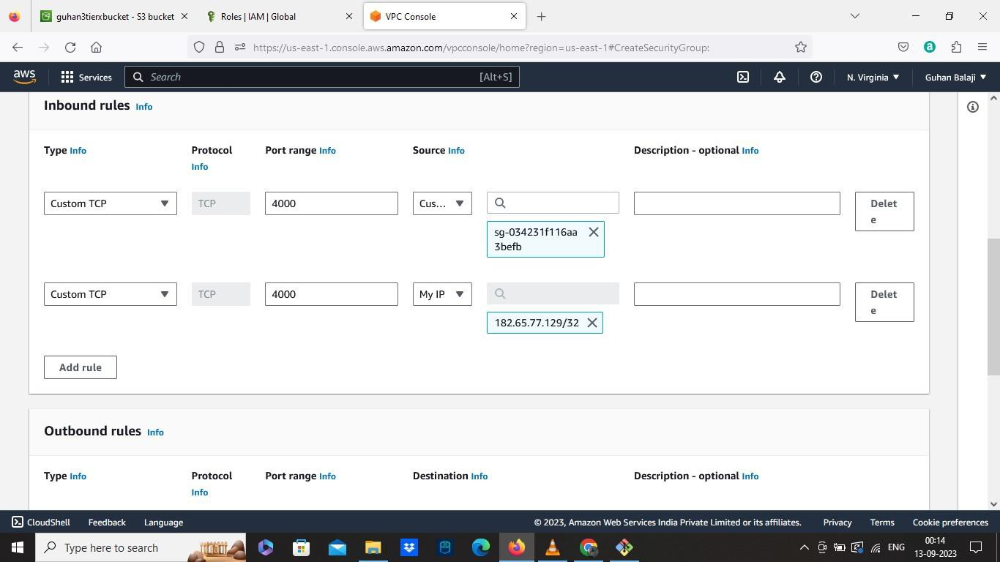

✓ Add inbound rule 2 – Port Range as 4000, Source as MY IP

• SG5 ( Database )

✓ Select our VPC.

✓ Add inbound rule 1 - Type as MY SQL/Aurora, Port as 3306, Source type as Private Instance SG.

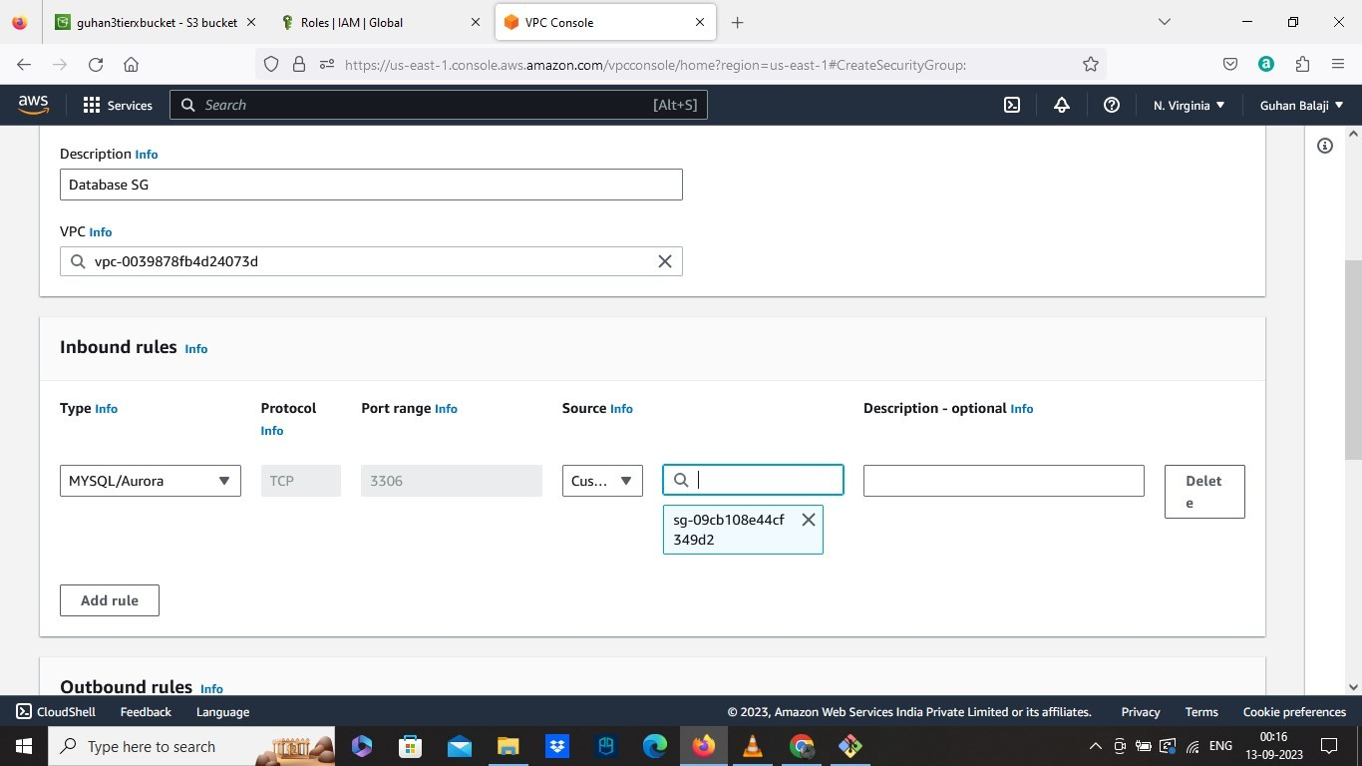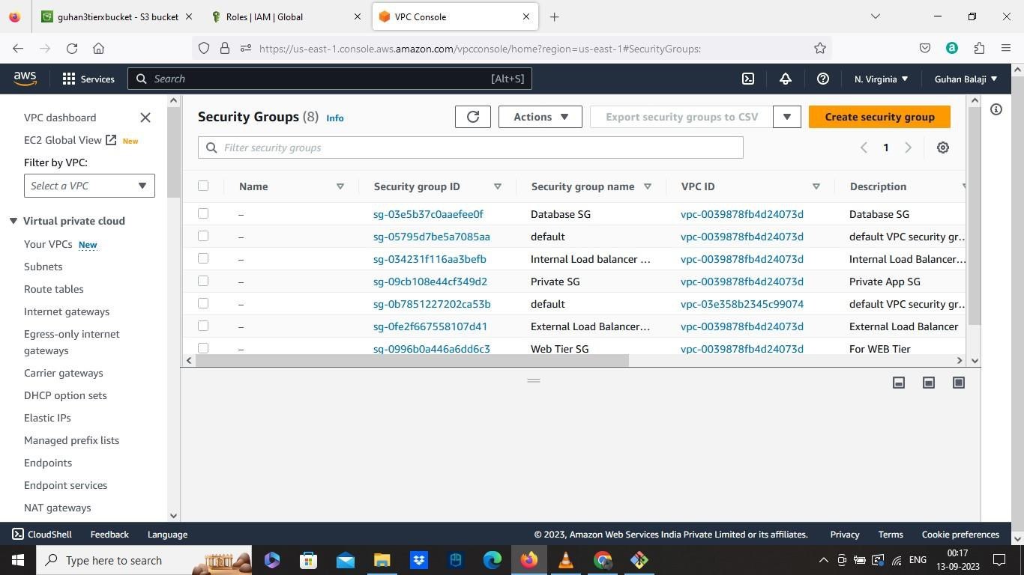

• Create Database in Amazon RDS

• Go to Subnet Groups

✓ Create DB subnet groups

✓ Select our custom VPC

✓ Choose Availability Zone as 1a,1b

✓ Select the two database private subnets AZ1,AZ2

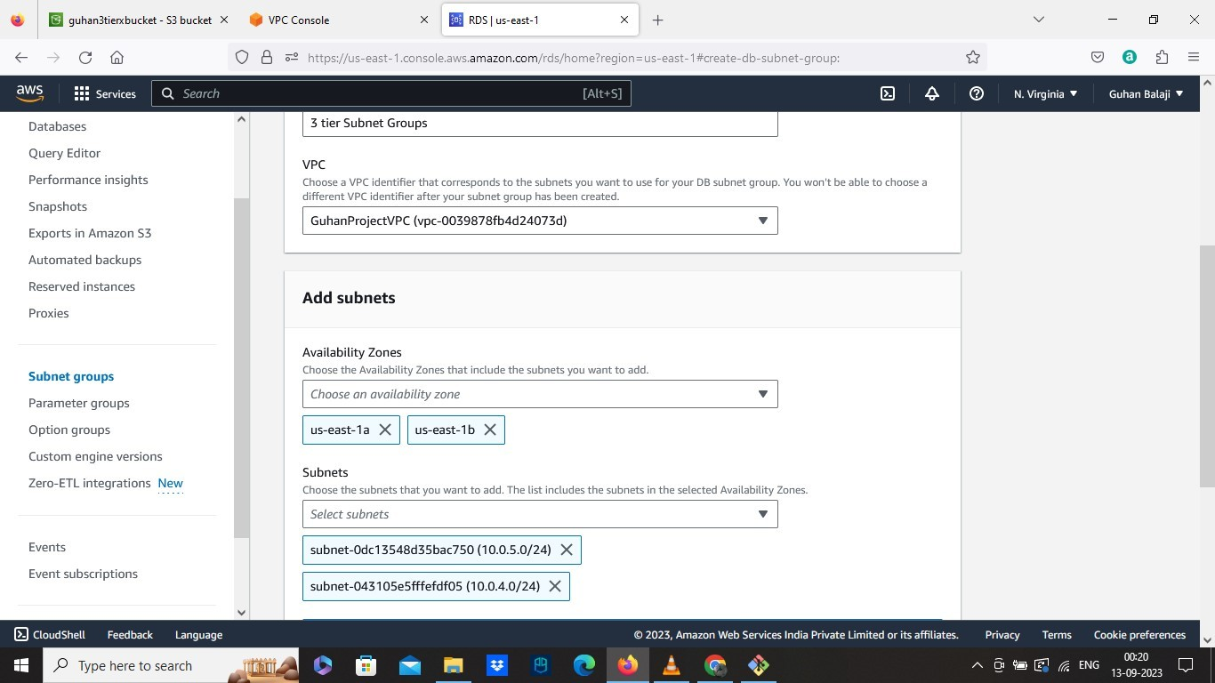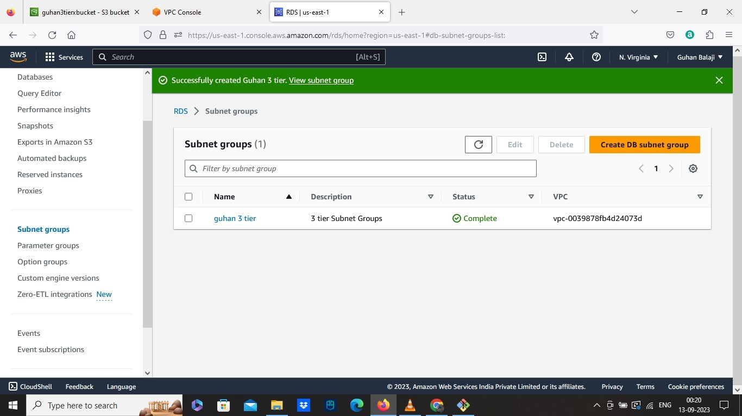

• Go to Databases

✓ Choose Database creation method as Standard Create

✓ Select Engine Type as AURORA/MYSQL

✓ Choose Templates as DEV TEST

✓ Create Master Username and Password

✓ Select Create An Aurora Replica in availability and durability

✓ Select Don’t Connect to an EC2 in Connectivity.

✓ Select Our VPC

✓ Select The Subnet Group we created

✓ Set Public Access as NO

✓ Select Existing Security group and choose Database SG

✓ Choose password authentication in Database authentication

✓ And finally Turn OFF the performance insights and create

Database.

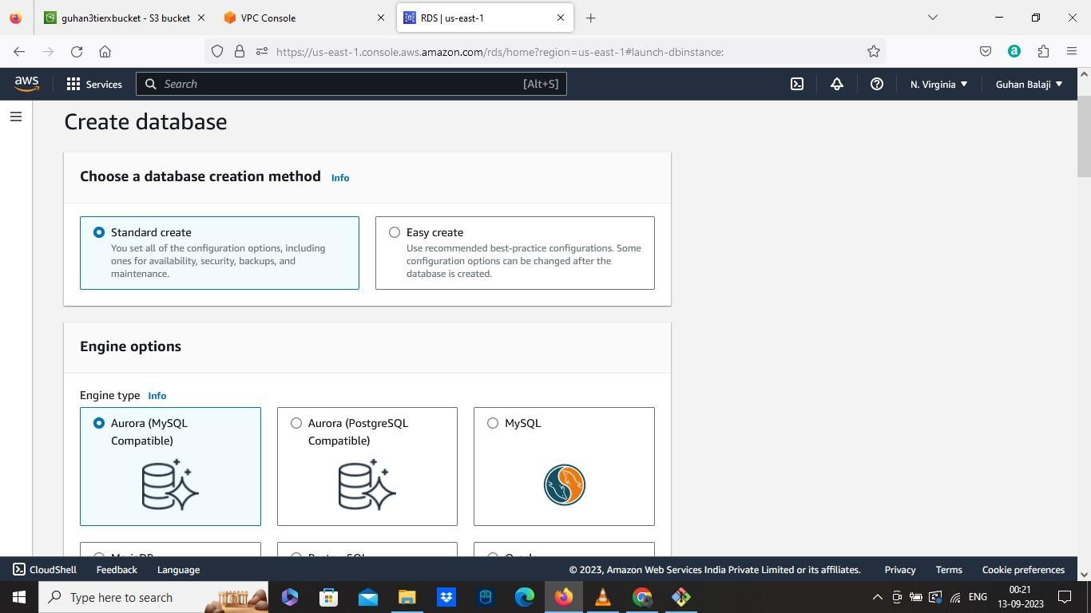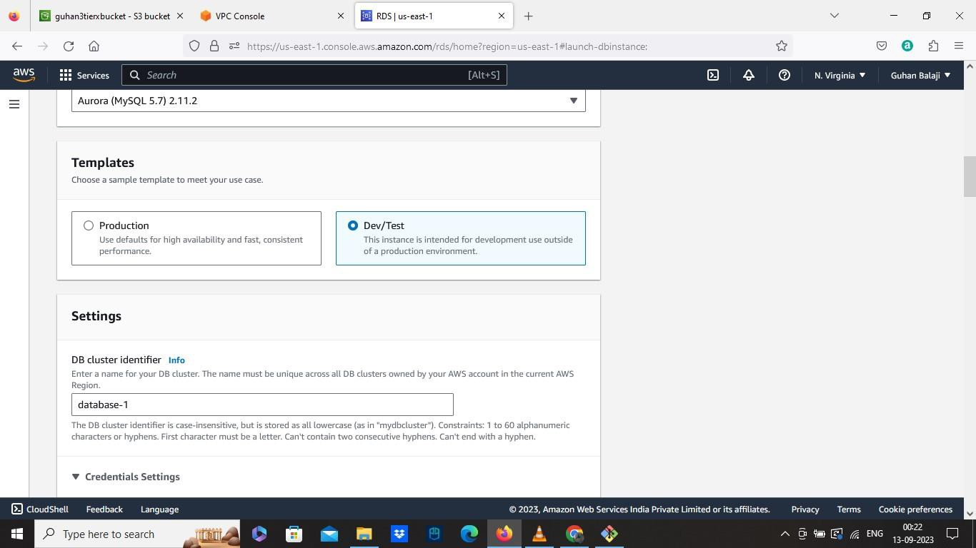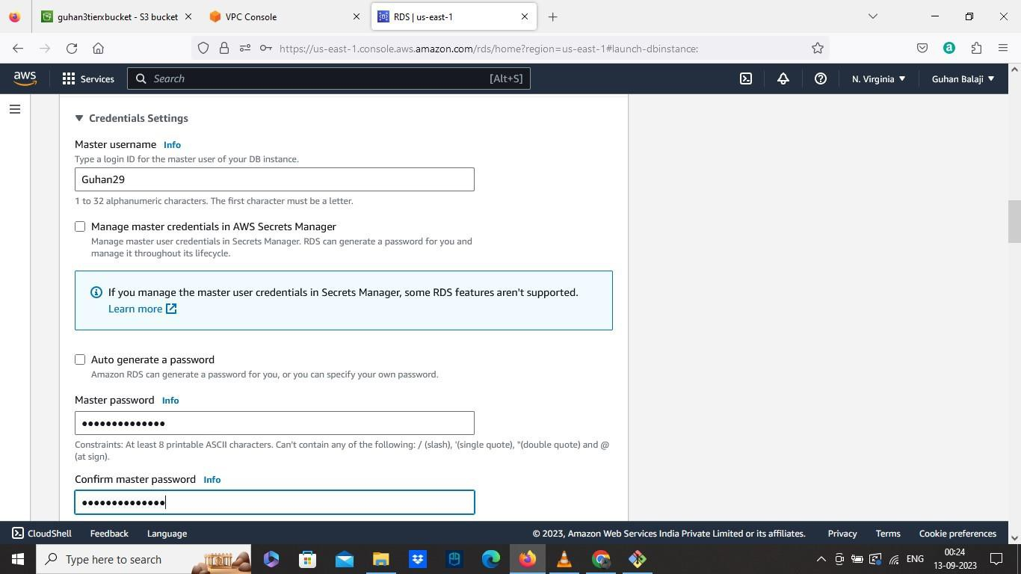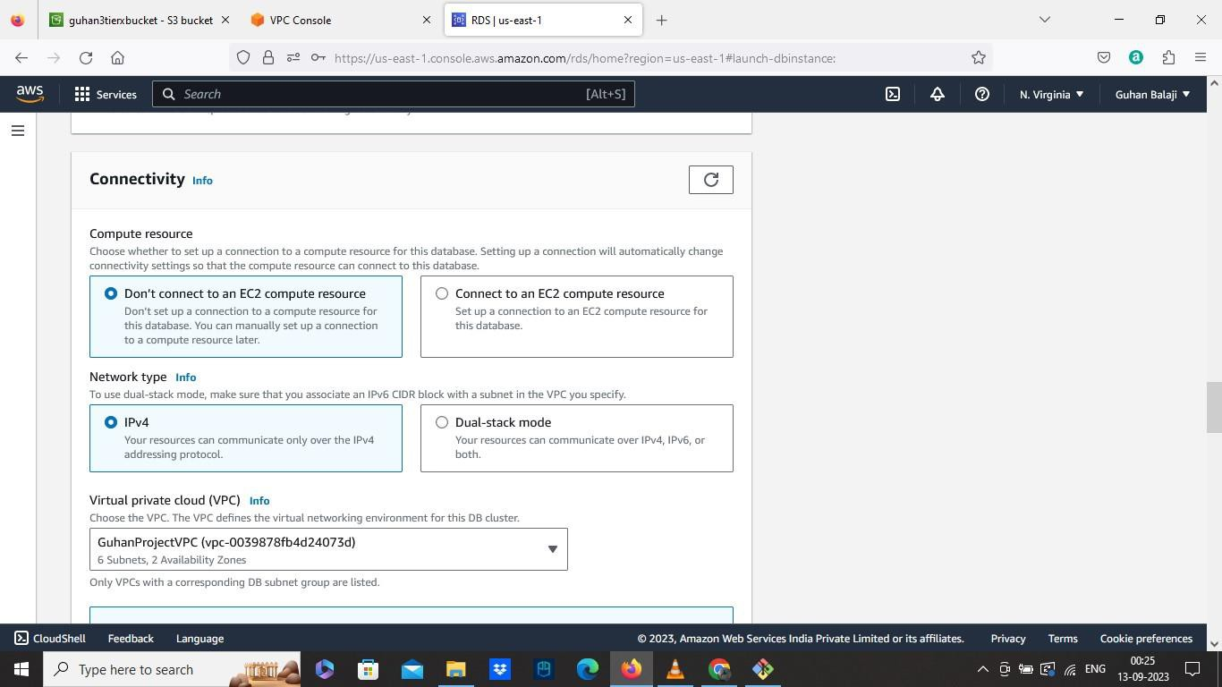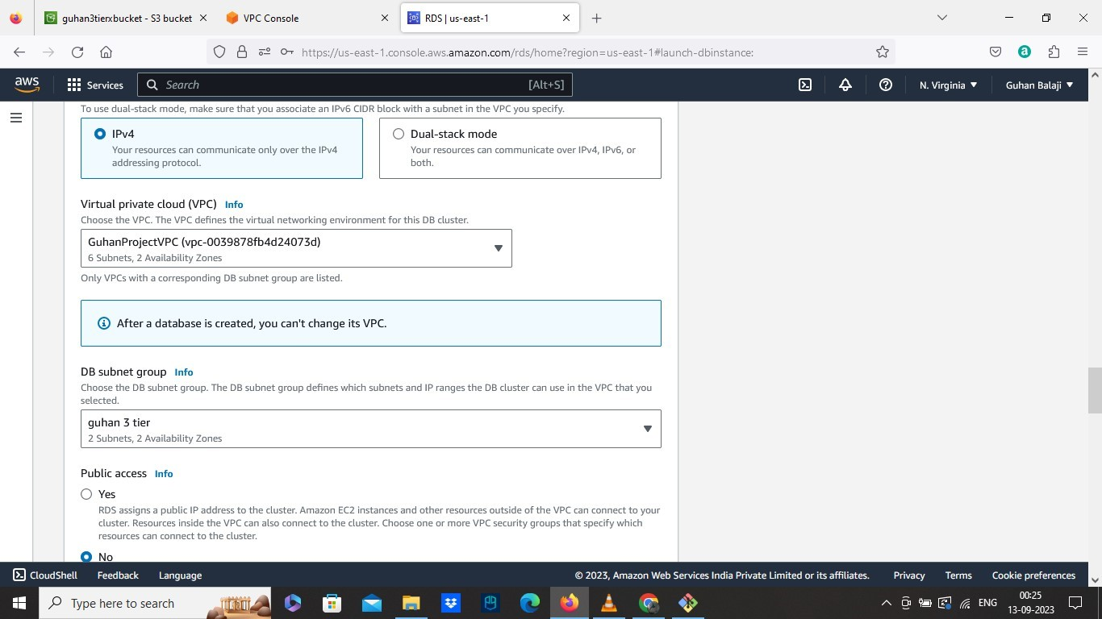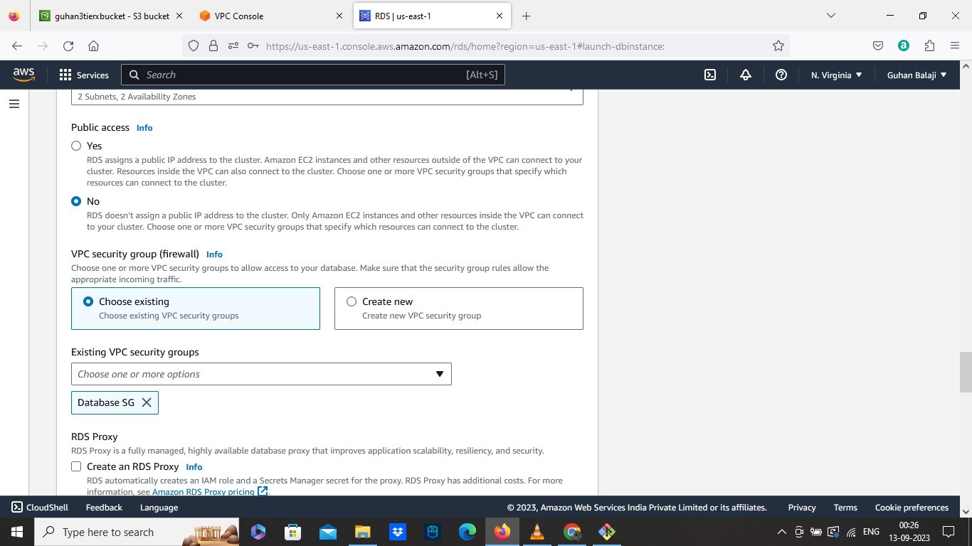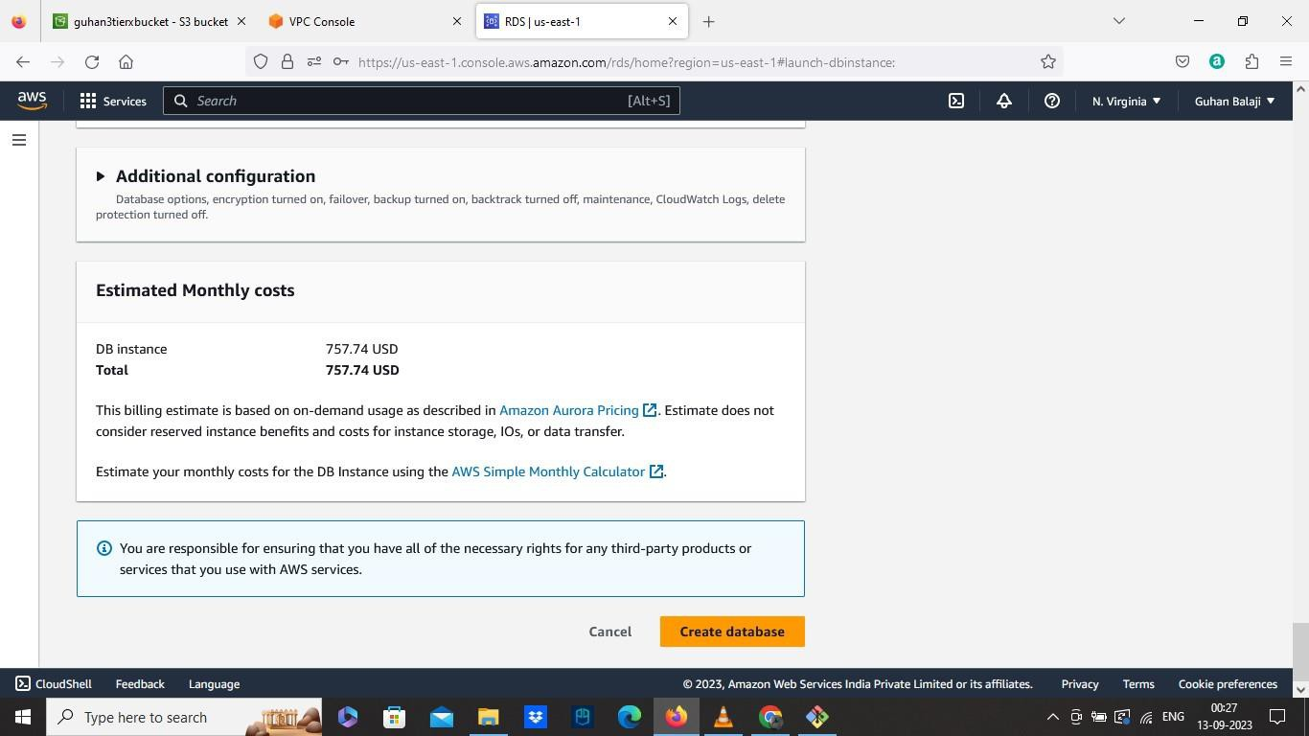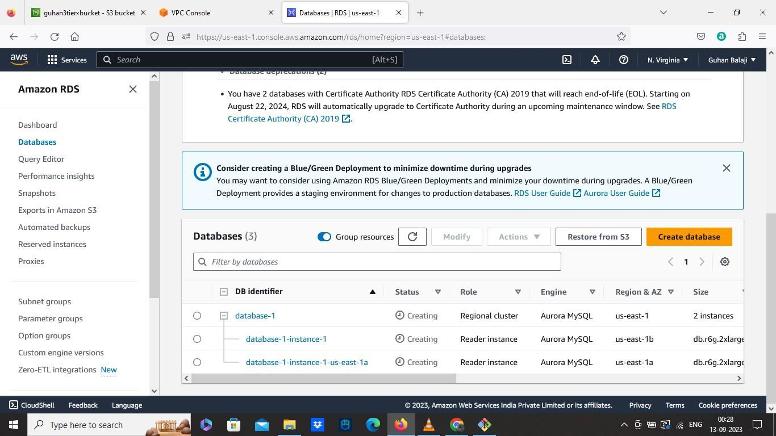

• Now for APP Tier

• Go to EC2

• Create an Instance

• Launch Instance

✓ Create Instance name

✓ Select without keypair

✓ Edit VPC and select our custom VPC

✓ In subnets, Select Private APP subnet AZ1

✓ Select Private Instance SG in Security group

✓ Select The IAM role we created

✓ Then Launch.

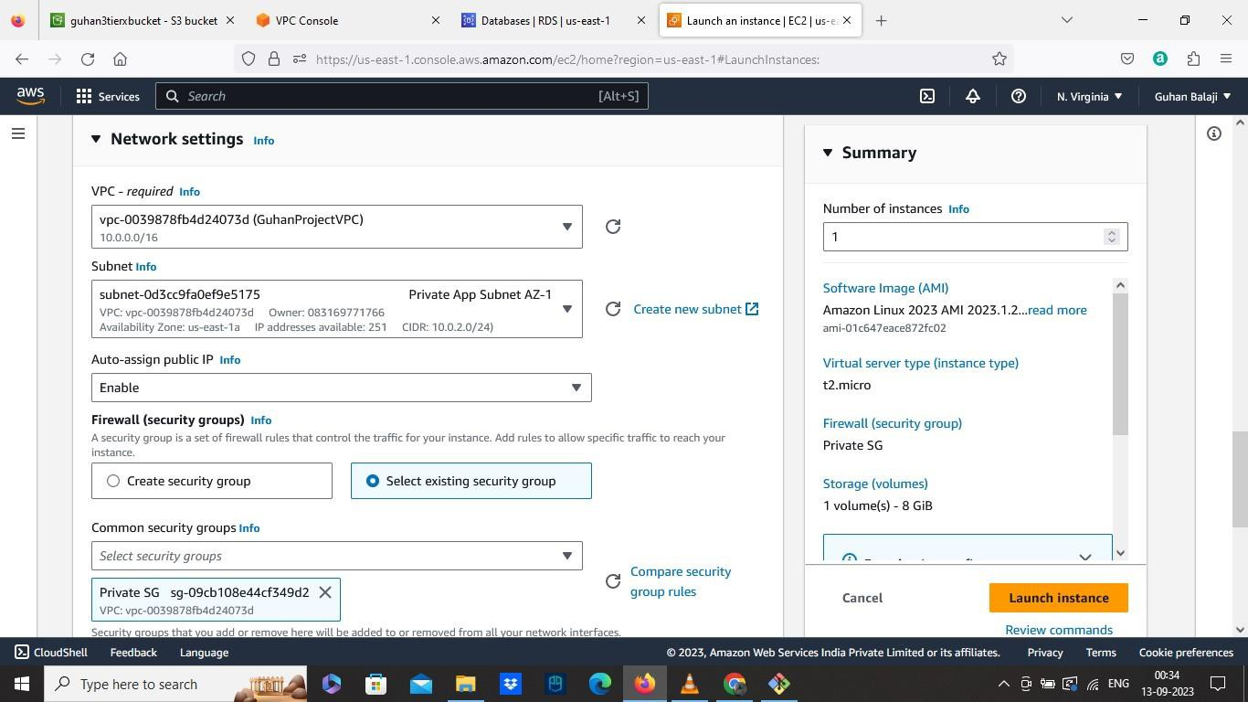

• Now connect to the terminal

• Use Command sudo -su ec2-user

• And Ping 8.8.8.8 to check the outside internet connectivity and google DNS

servers.

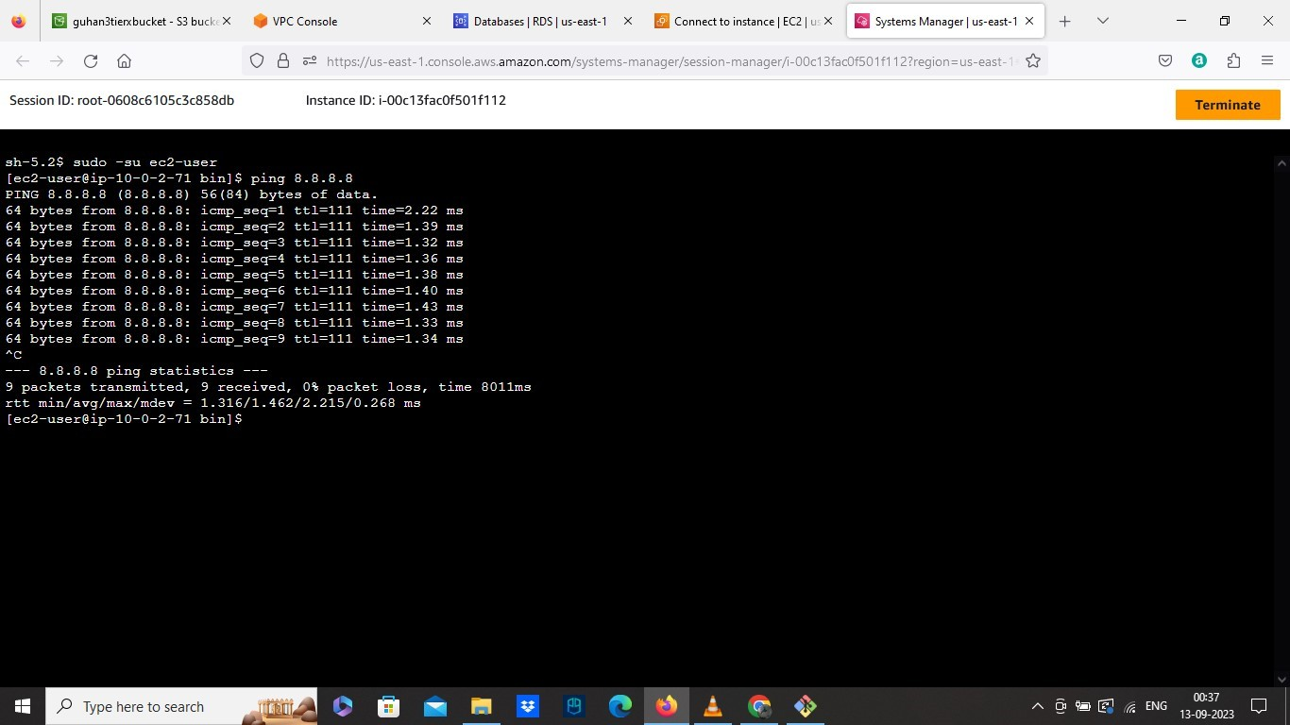

• Press Ctrl + c to stop.

• Now download the Sql package

✓ Use command: sudo wget https://dev.mysql.com/get/mysql57- community -release-el7-11.noarch.rpm

✓ Then Use command: sudo rpm --import

https://repo.mysql.com/RPM-GPG-KEY-mysql-2022

✓ Then Install SQL packages using this command: sudo yum install

[h tt p s:// de v.mysq l.co m/g e t/ mysq l57 -co mmu n ity -rele a se -e l7 -](https://dev.mysql.com/get/mysql57-community-release-el7-11.noarch.rpm)

[11 .n oa rch. rpm](https://dev.mysql.com/get/mysql57-community-release-el7-11.noarch.rpm)

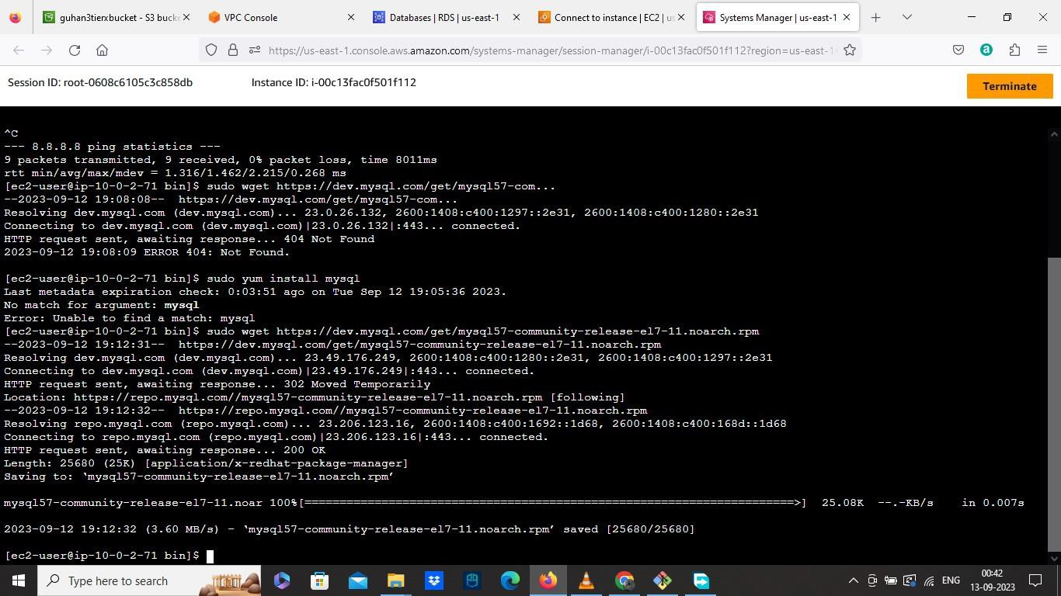

✓ Then Use command sudo yum install mysql to install sql

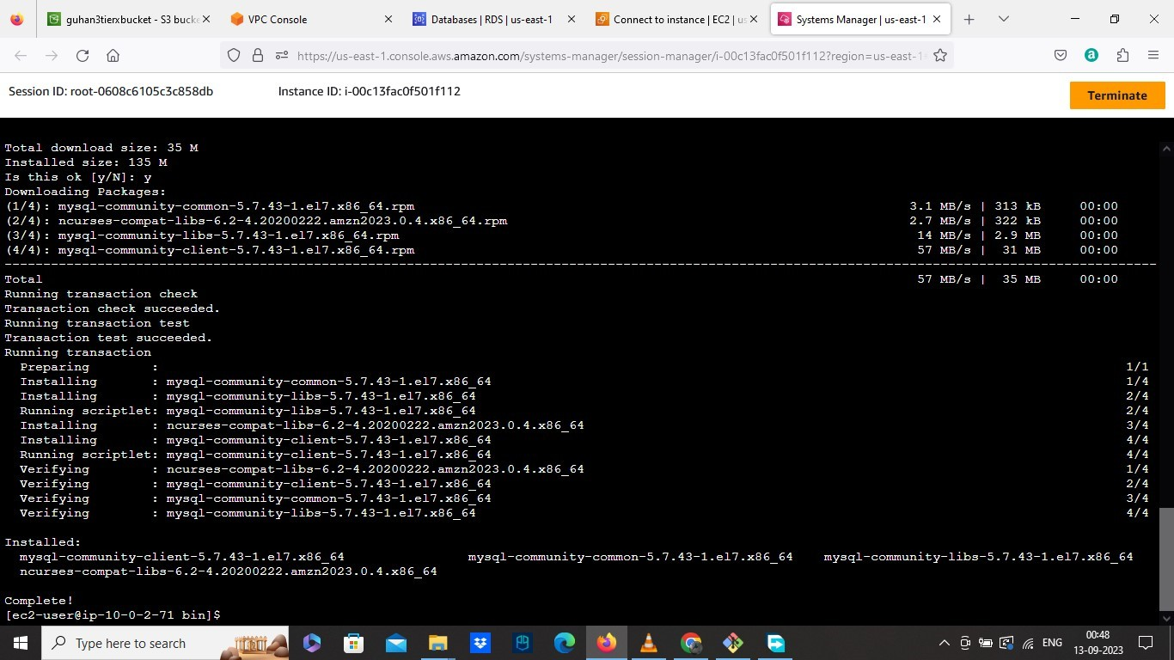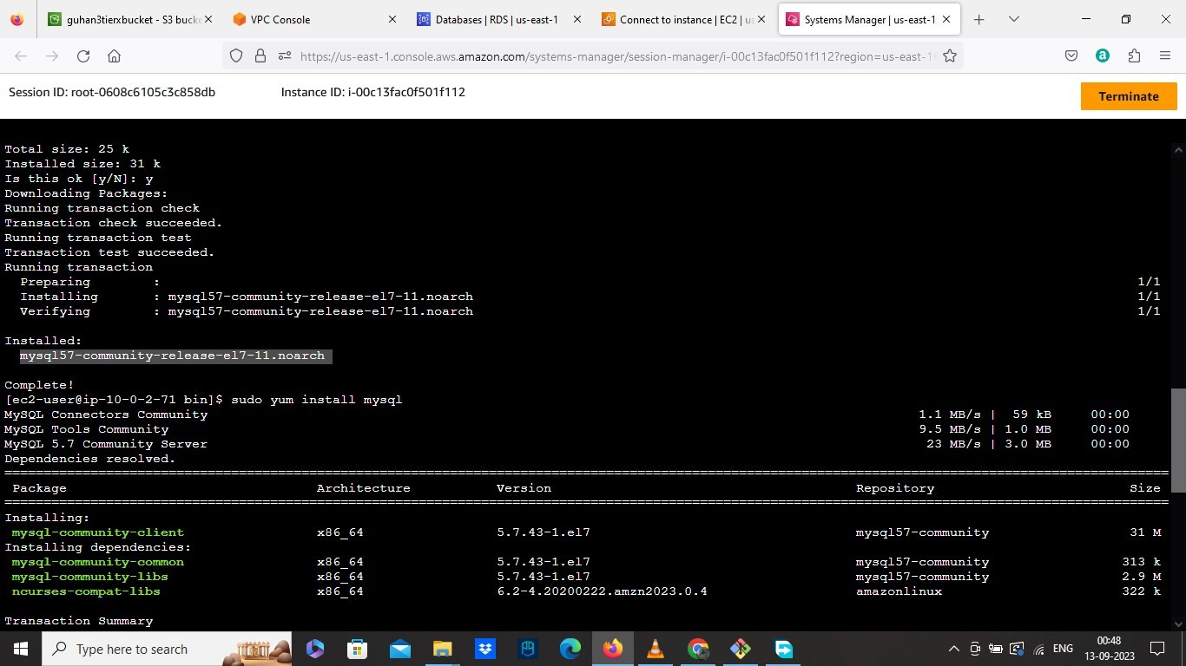

• Use Command mysql

• Then Initiate your DB connection with your Aurora RDS writer endpoint. By the command: mysql -h database-1-instance-1.cxndmld5i4pt.us-east-

1.rds.amazonaws.com -u Guhan29 -p

• Which in this command our rds writer endpoint and user name is added.

• Then Enter the Password You Already created for the database.

• Now Create a database by using this command and name it : CREATE DATABASE webappdb;

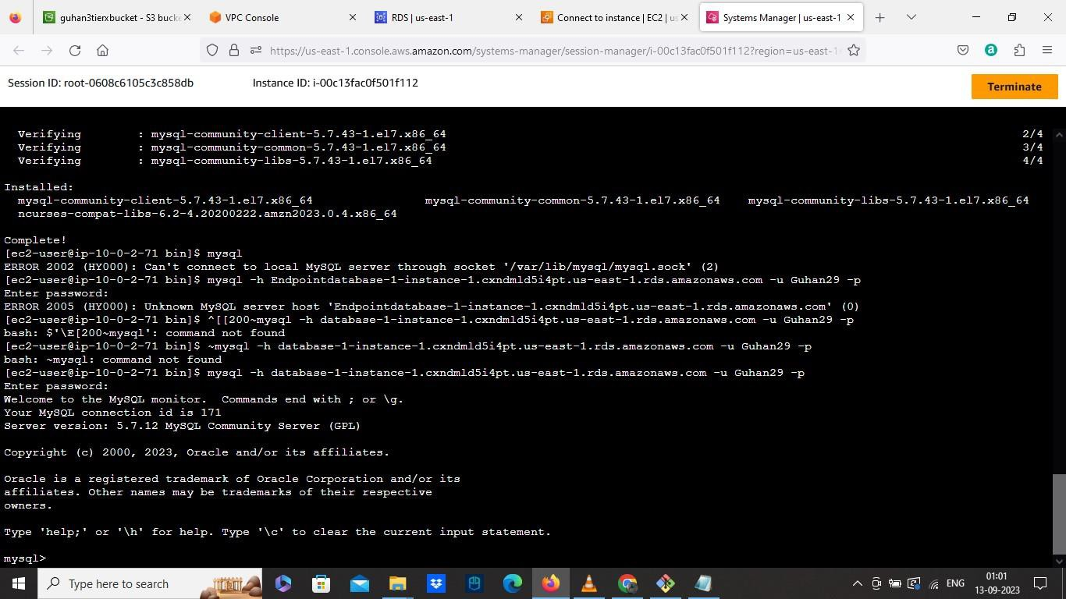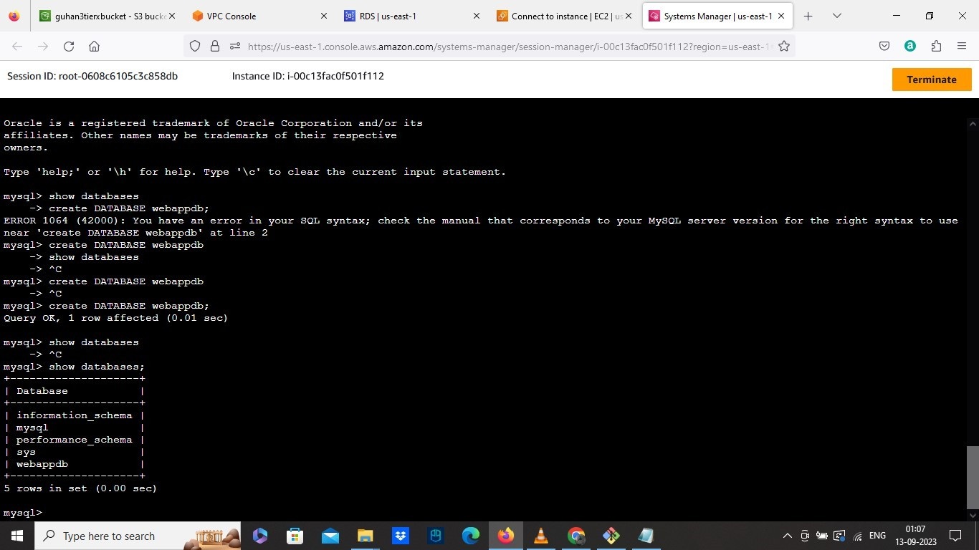

• Now Use this command to check whether the database we created is available: SHOW DATABASES;

• Change to your database by using this command: USE webappdb;

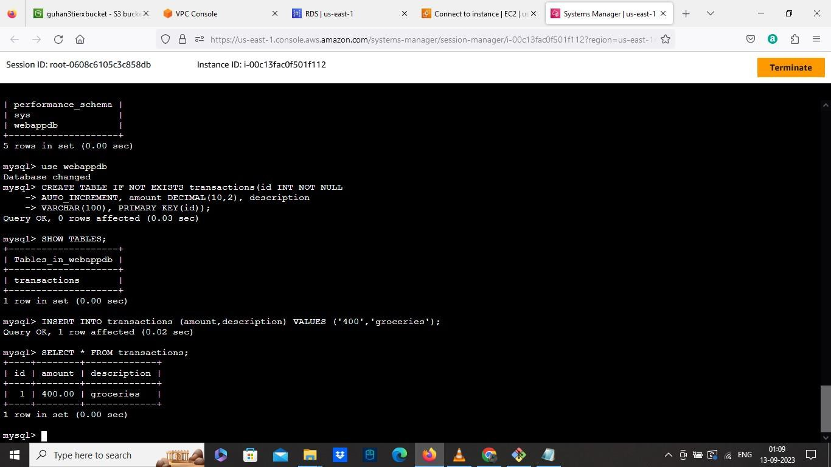

• Create a table by using this command: CREATE TABLE IF NOT EXISTS

transactions(id INT NOT NULL

AUTO_INCREMENT, amount DECIMAL(10,2), description

VARCHAR(100), PRIMARY KEY(id));

• Check the created table: SHOW TABLES;

• Insert the data in the table by using this command: INSERT INTO transactions

(amount,description) VALUES ('400','groceries');

• Check The data added by: SELECT * FROM transactions;

• Then type exit to exit the SQL.

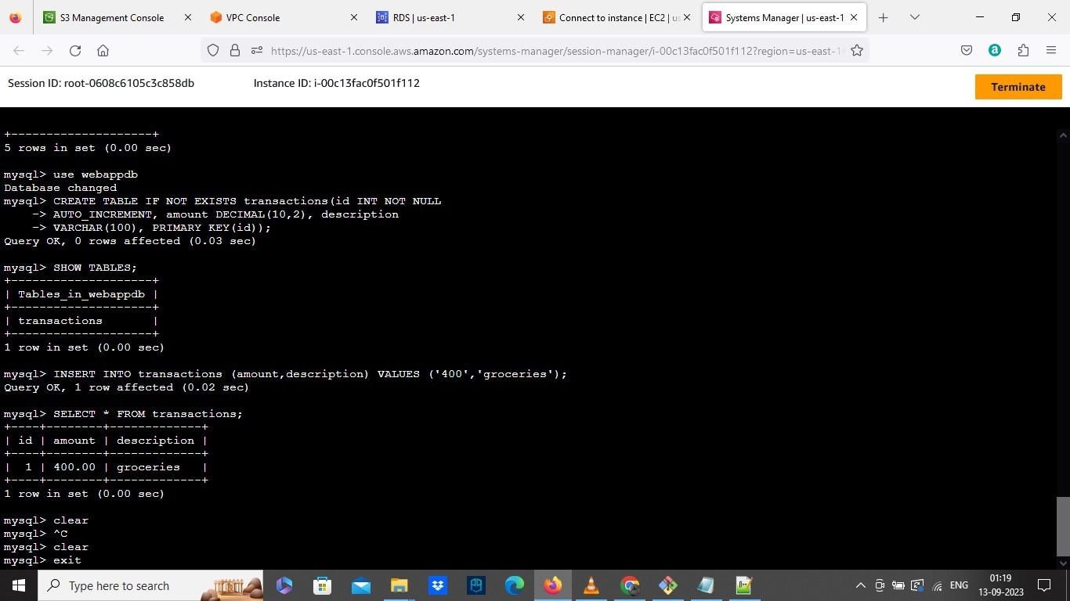

• Then go to S3 bucket we created

• The DB config file which we already downloaded from GitHub, need to edit before uploading in S3.

• Where the details will be empty which we downloaded from Github

• Now open the DB config file with Notepad++

• Then Add the required details of the Database we created, add Writer endpoint in the DB host Field and webappdb in DB database field.

• After that save the file, and upload to S3 bucket we created.

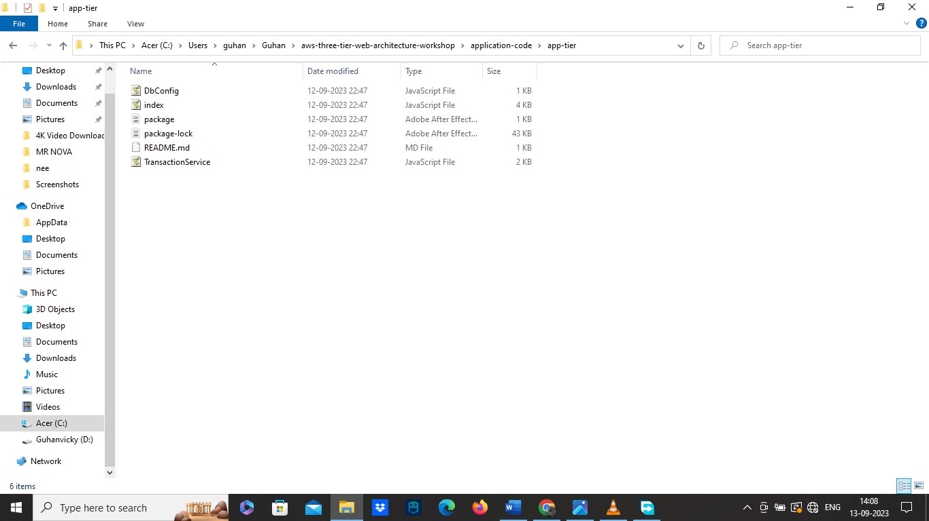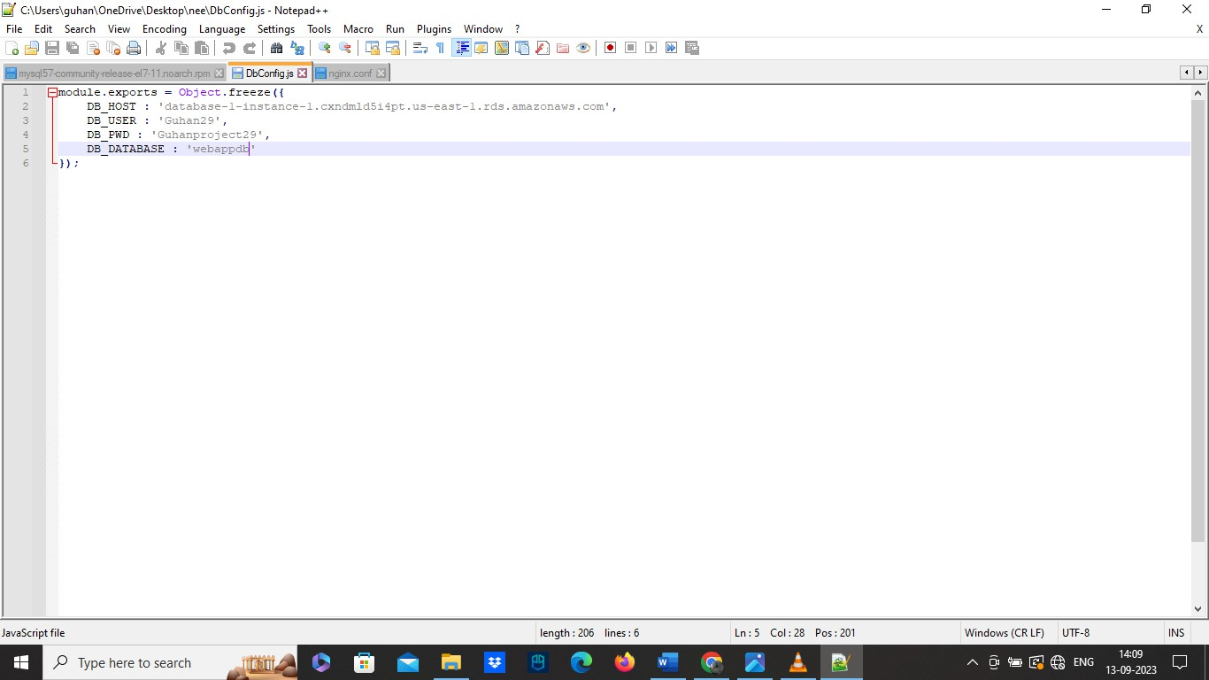

• Now Upload the app tier folder to the S3 bucket also.

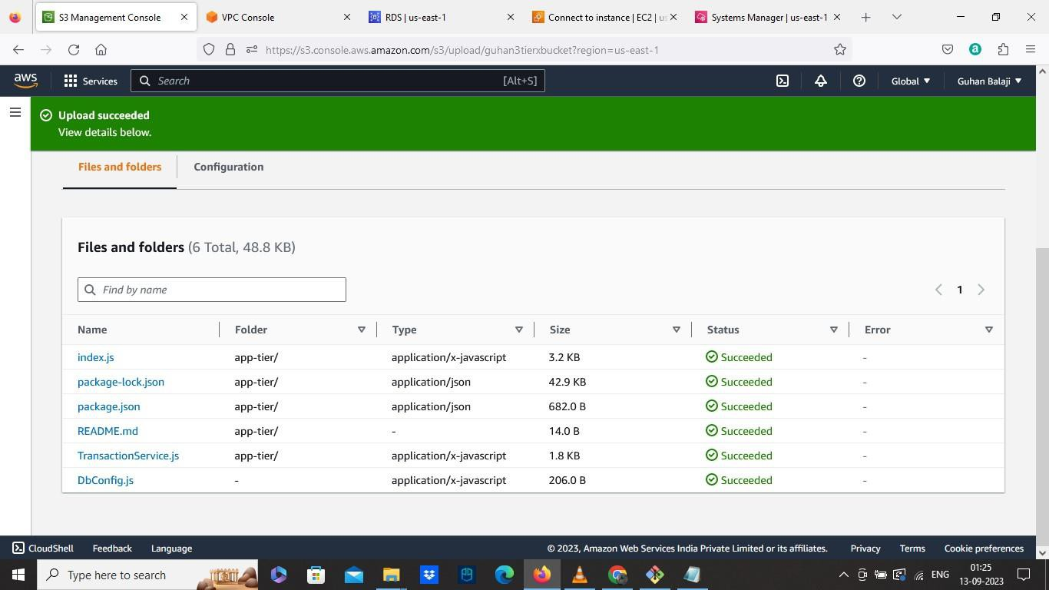

• Also move the config file to app tier folder

• Now we need to install necessary components to run in backend

• Install Node version manager by running this command: curl -o- https://raw.githubusercontent.com/nvm-sh/nvm/v0.38.0/install.sh | bash

source ~/.bashrc

• Then we need to instal Node.js and use it by running this command: nvm install

16

nvm use 16

• Install pm2, which make the nodejs app active even when we exit the instance.

Use this command to install: npm install -g pm2

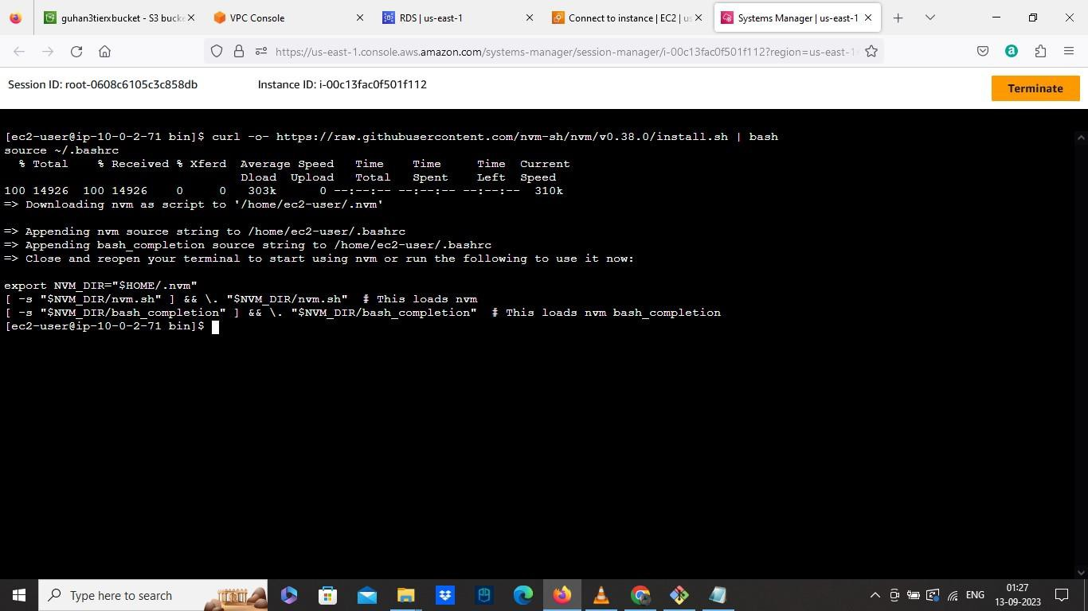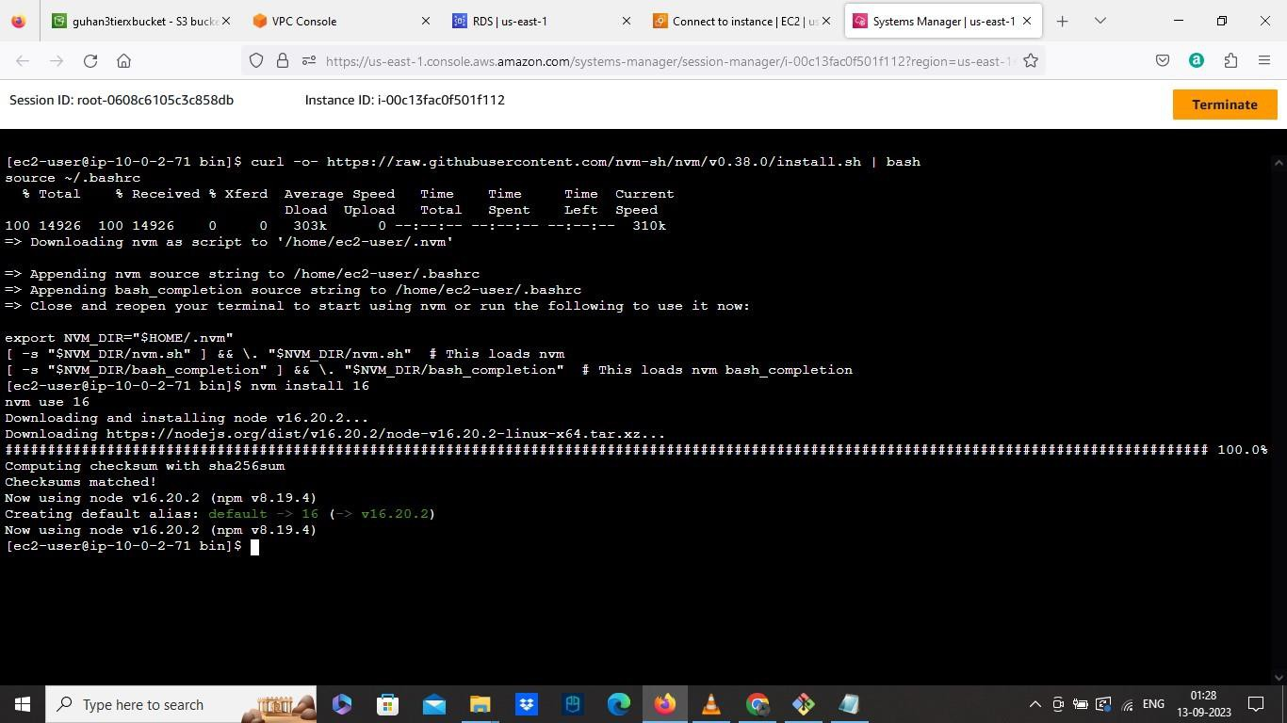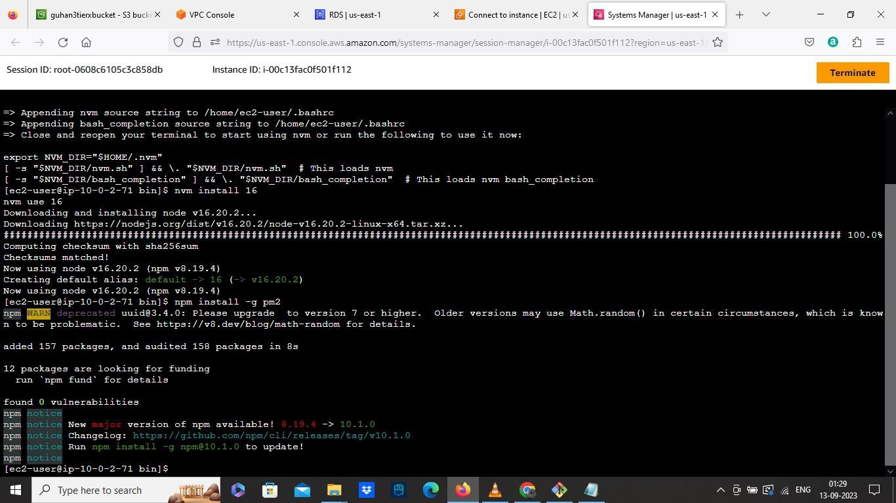

• Change the directory cd

• Now we need to fetch and download the code from the S3 bucket, so we need to use this command: aws s3 cp s3://guhan3tierxbucket/app-tier/ app-tier -- recursive

• Add our bucket name in the command and run

• Now download the entire folder ls -lrtr

• Then Switch to app tier by using cd a pp -tie r/

• Activate the pm2 we installed by using this command: pm2 start index.js

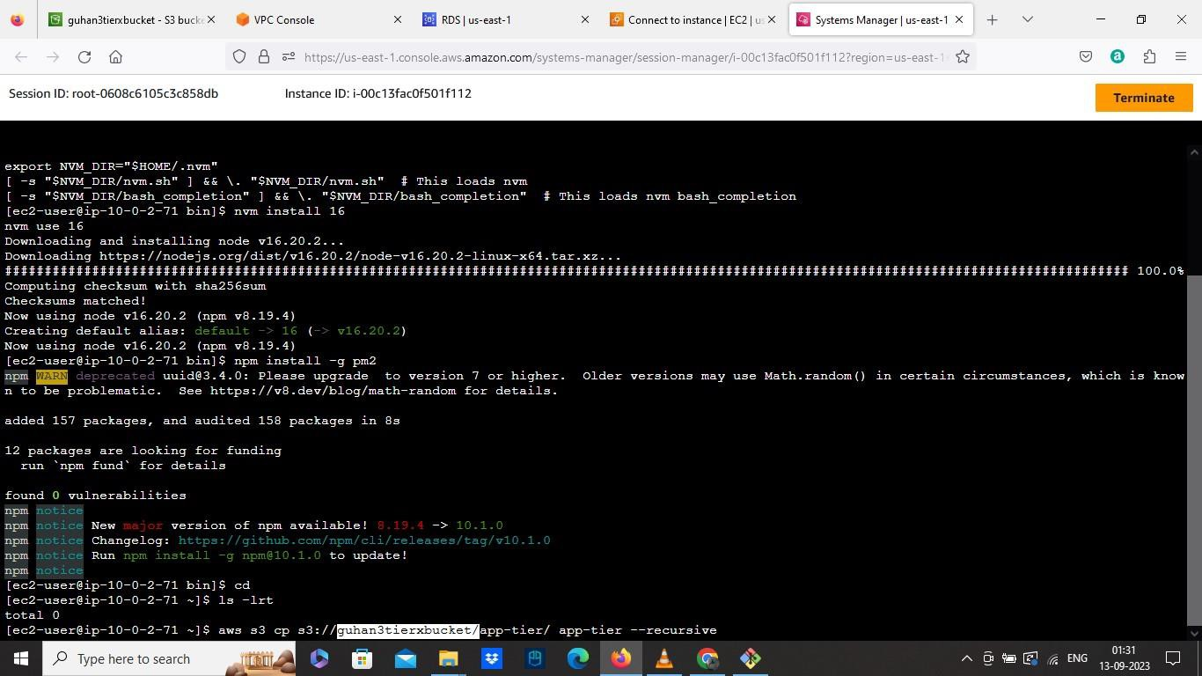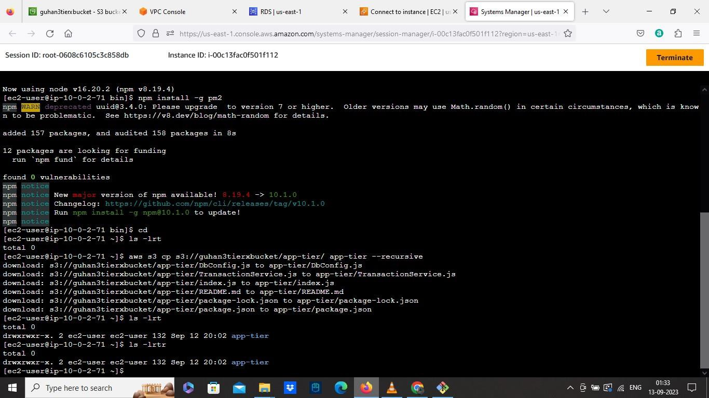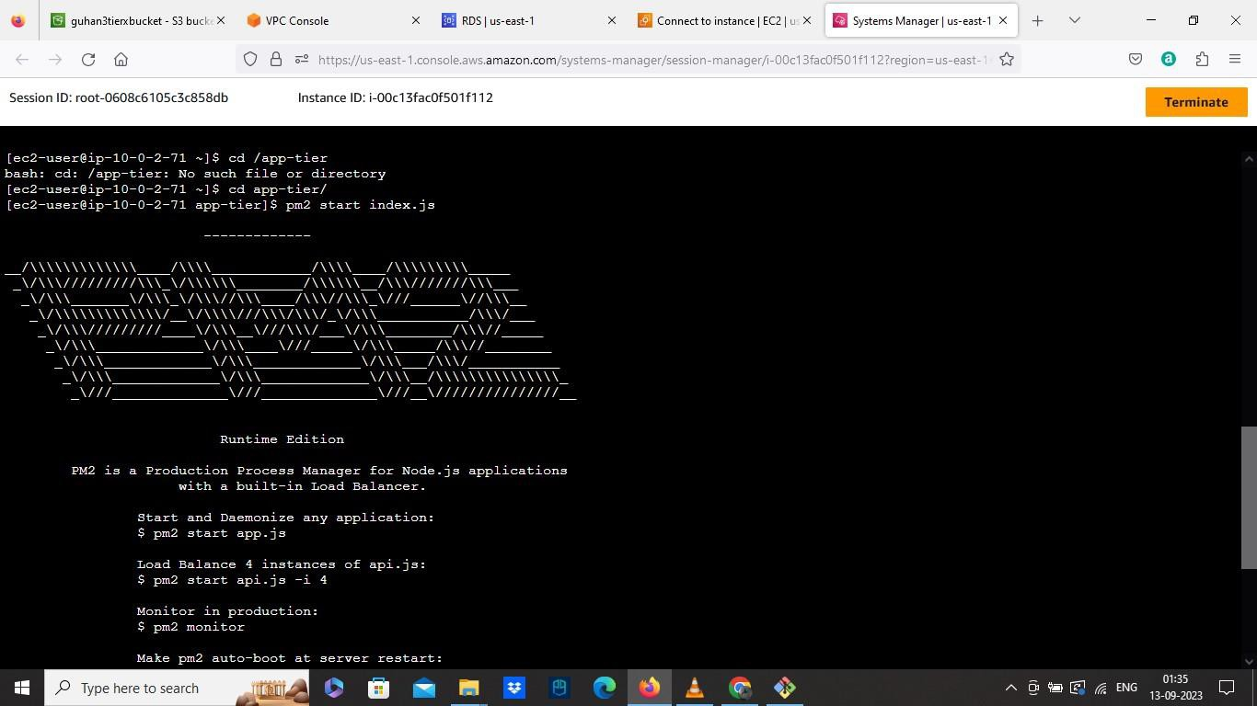

• To check the app is running, run the command: p m2 list and check the online and error status by using this command: p m2 lo g s

• Now make the app to keep running even after exit, run this command: p m2

sta rtu p and run the command it display next.

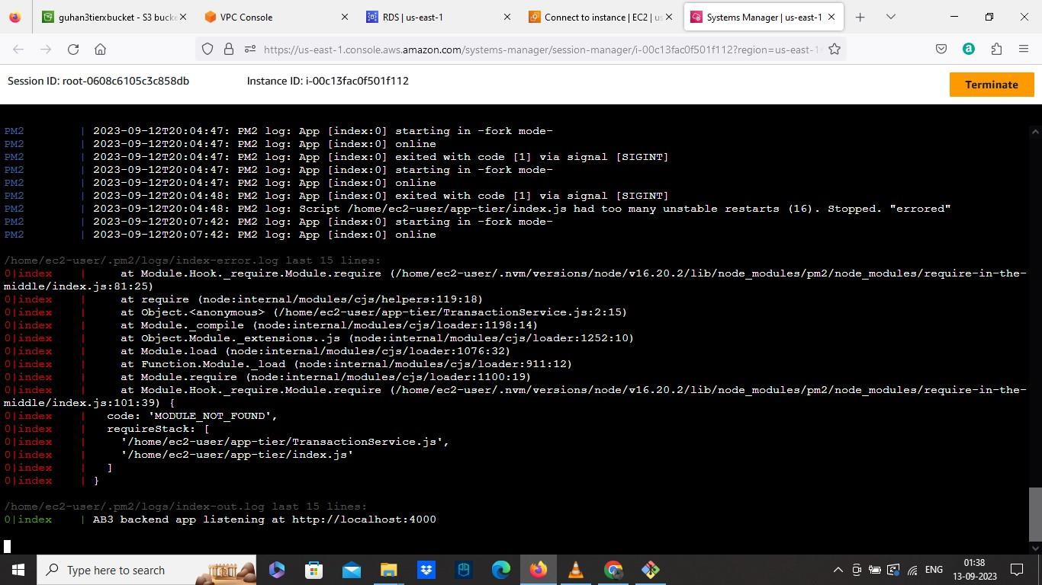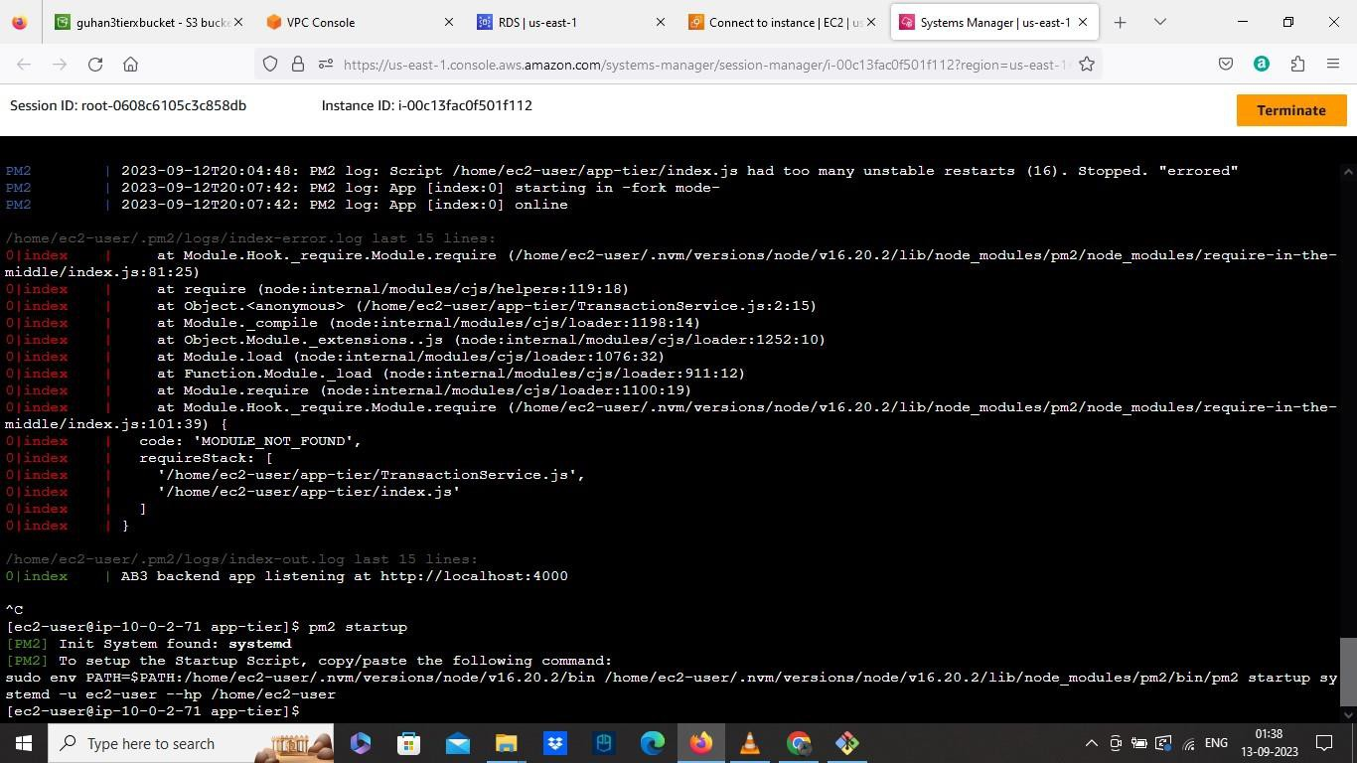

• Save the configuration by: pm2 sa ve

• Test the app health by : curl http://localhost:4000/health

• Test the database connection by using: curl http://localhost:4000/transaction

• Then the app layer will be created.

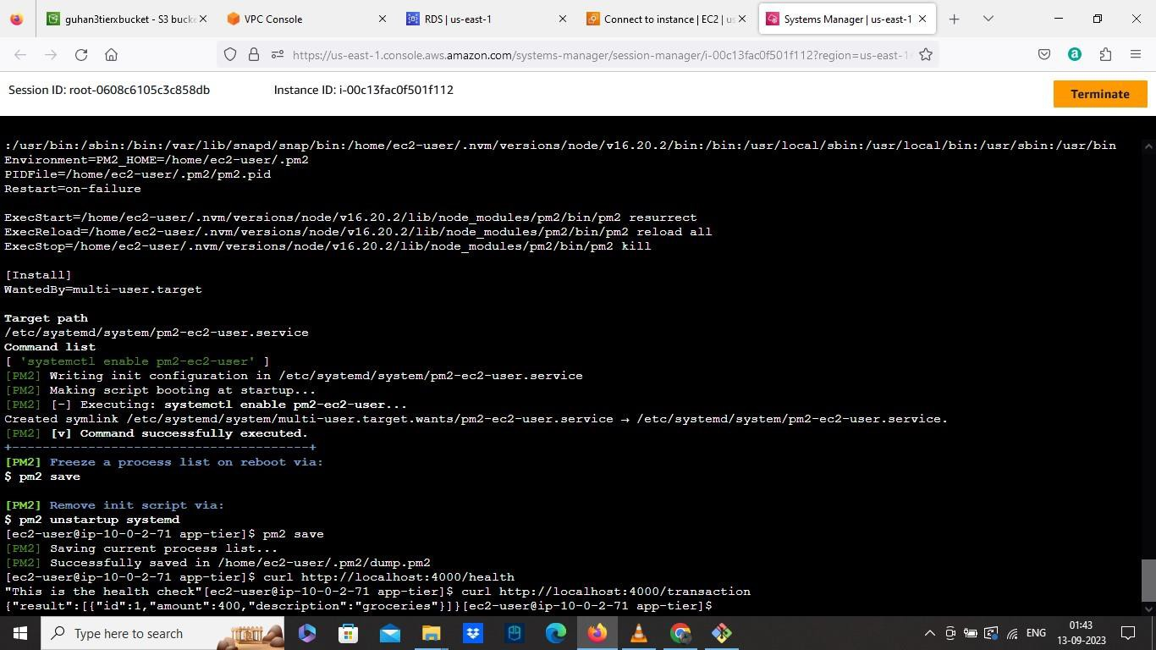

• Go to EC2

➔ Select the Instance we created and create an Image AMI

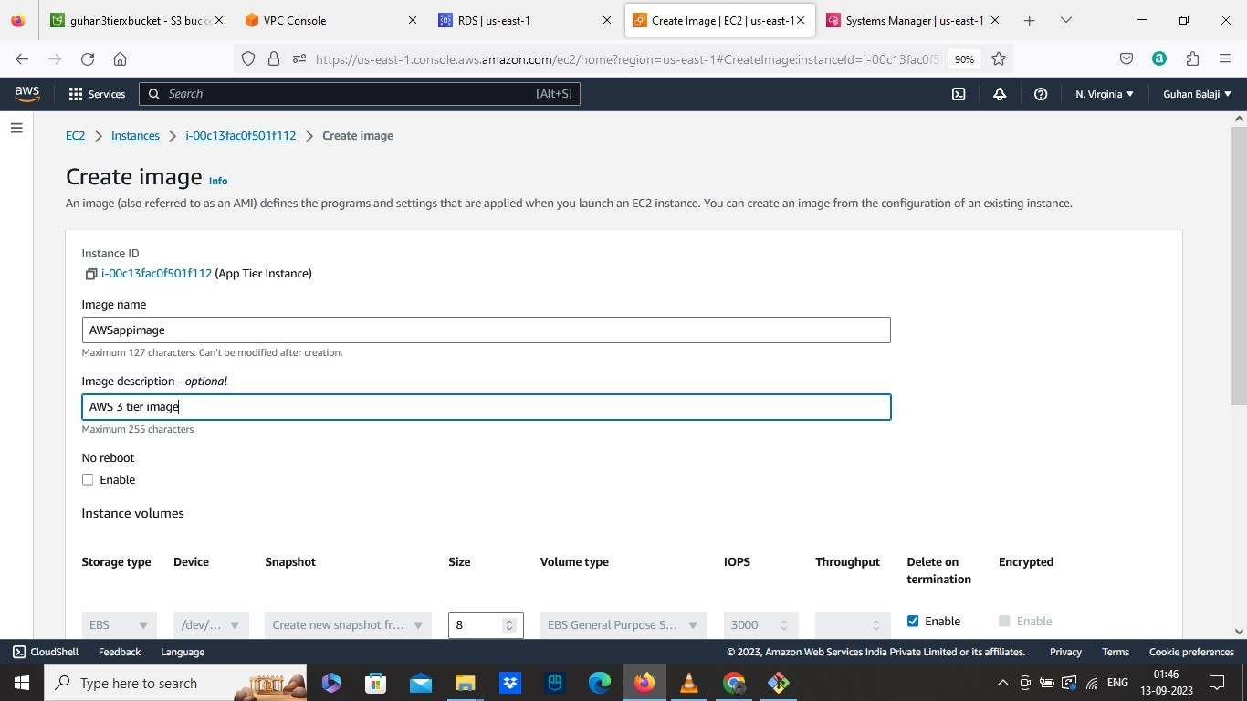

• Go to Target Groups

➔ Choose Target type as Instance.

➔ Give a name to the target group we created

➔ Set the port to 4000 and protocol to HTTP

➔ Select our custom VPC

➔ Change the values to 2 in healthy threshold and the TG will be created.

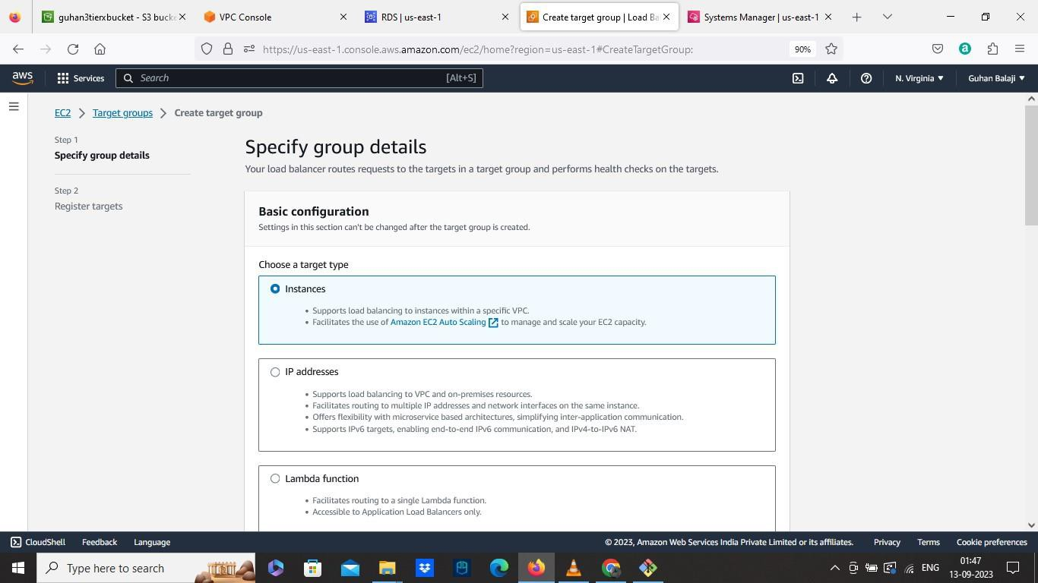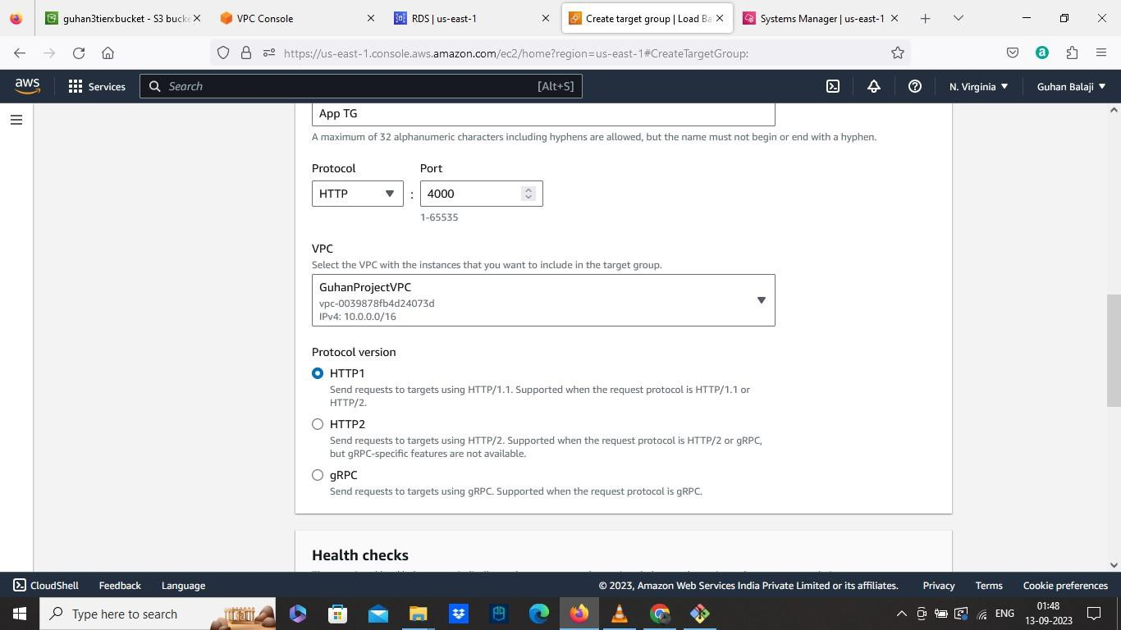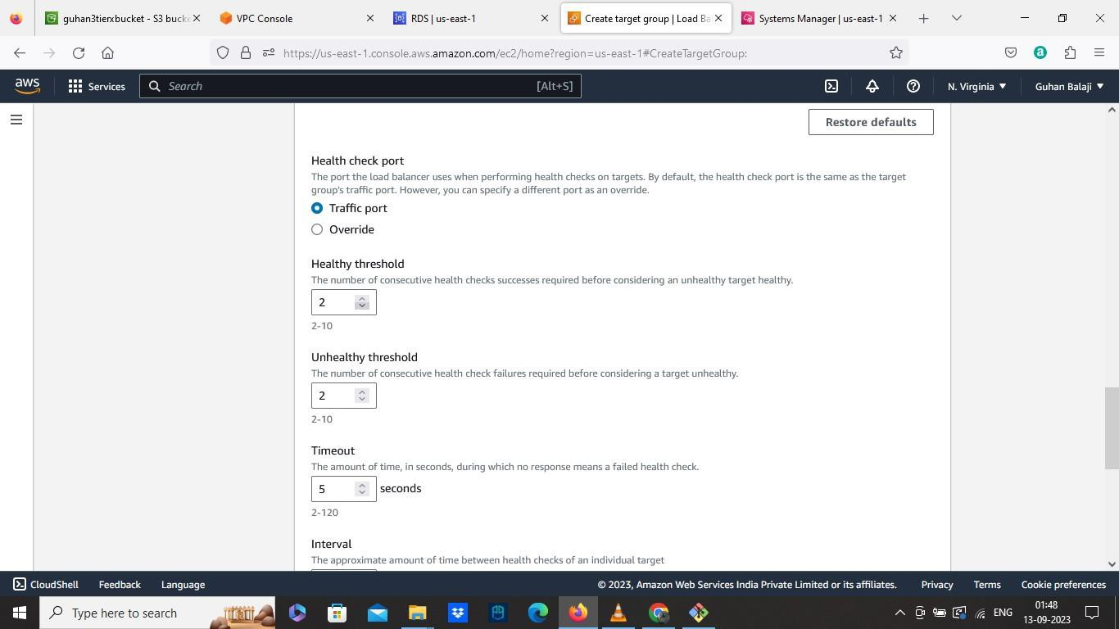

• Create Load Balancer

➔ Select the scheme as Internal

➔ Select our custom VPC

➔ In Mapping, Select the two private App Subnet az1, az2

➔ Select the existing Internal Load Balancer Security Group

➔ In Listeners and routing, Set the port to 80 and select The Target group we created in Forward.

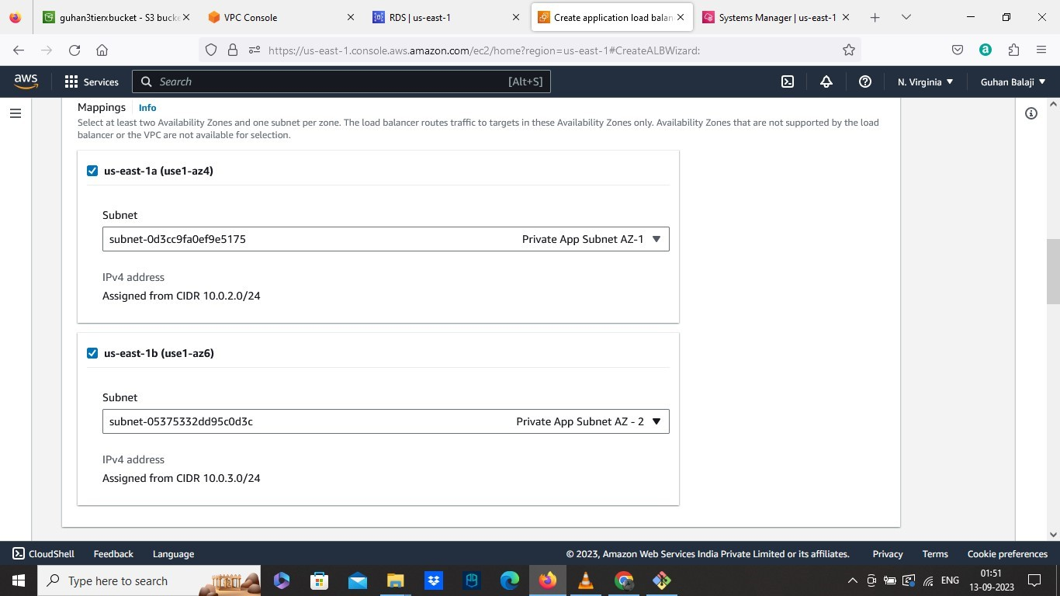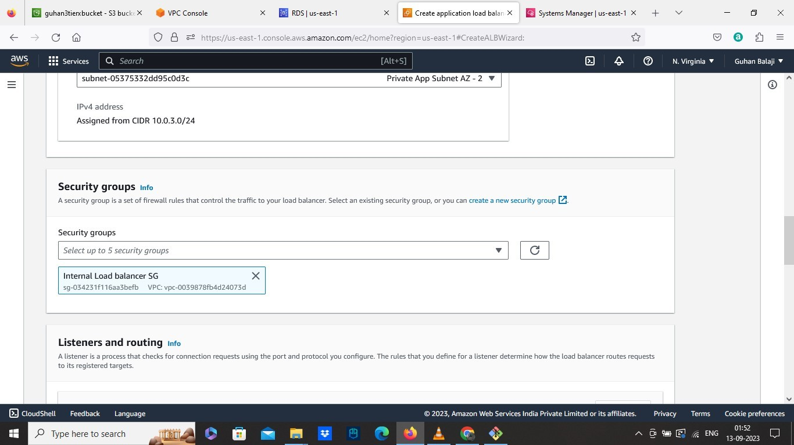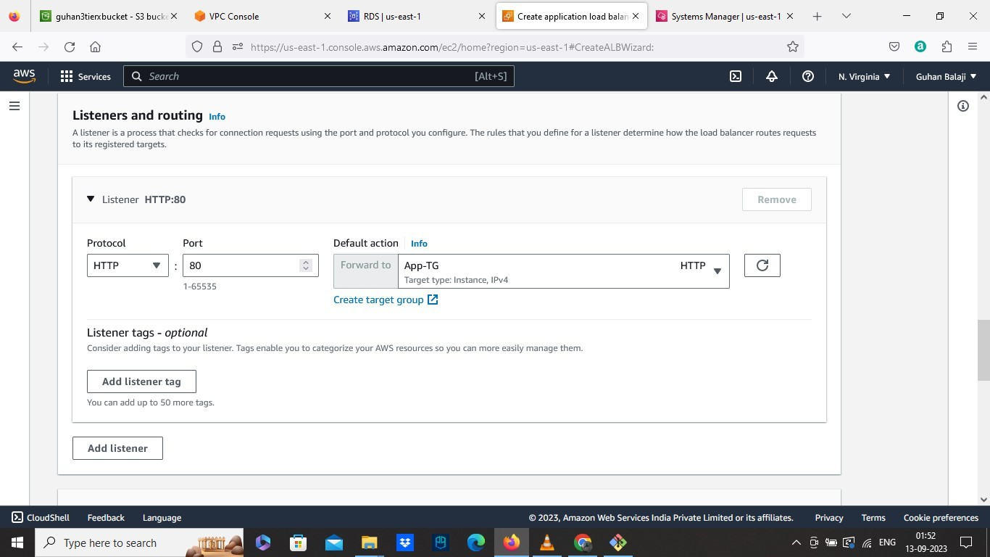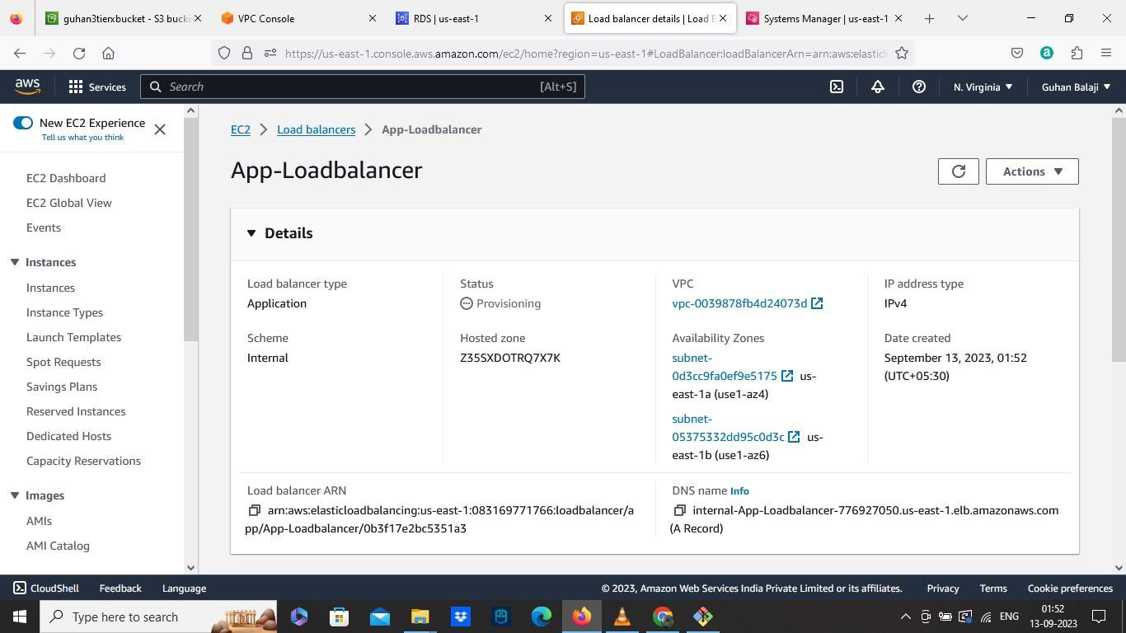

• Create The Launch Template

➔ Select our EMI from App Instance

➔ Set Instance Type as Free Tier

➔ Select The Private Instance SG in Security Group

➔ Choose The IAM role we created

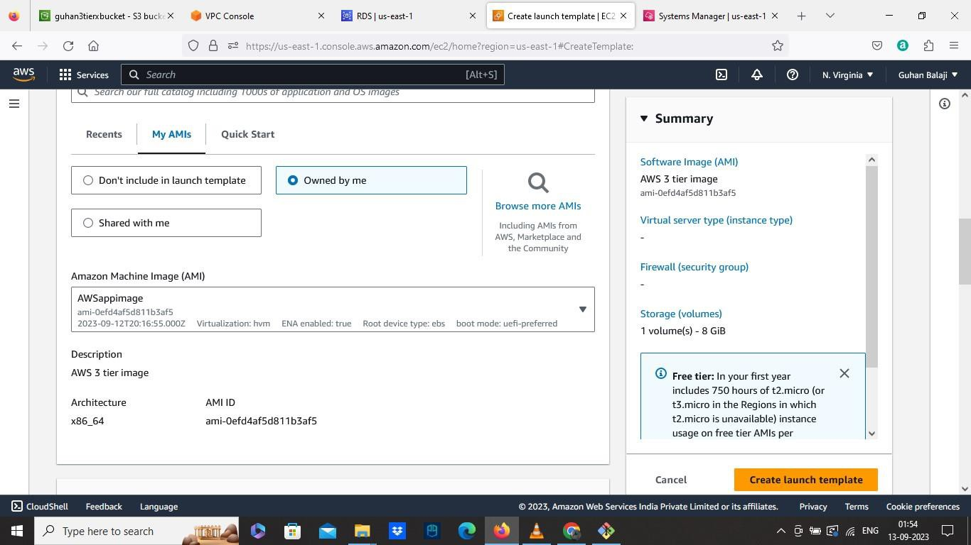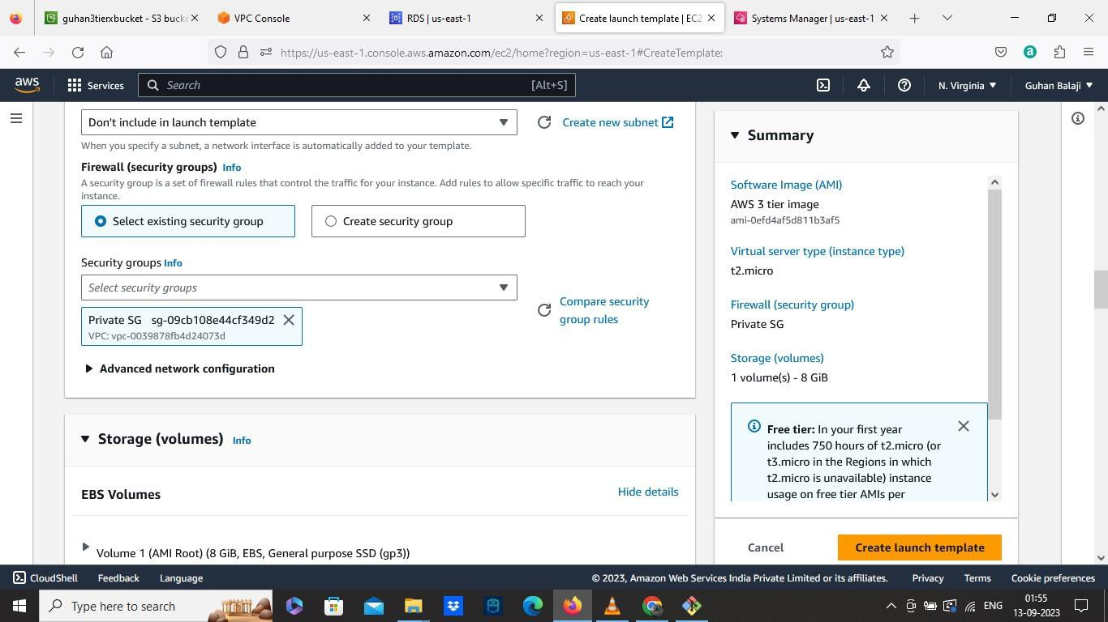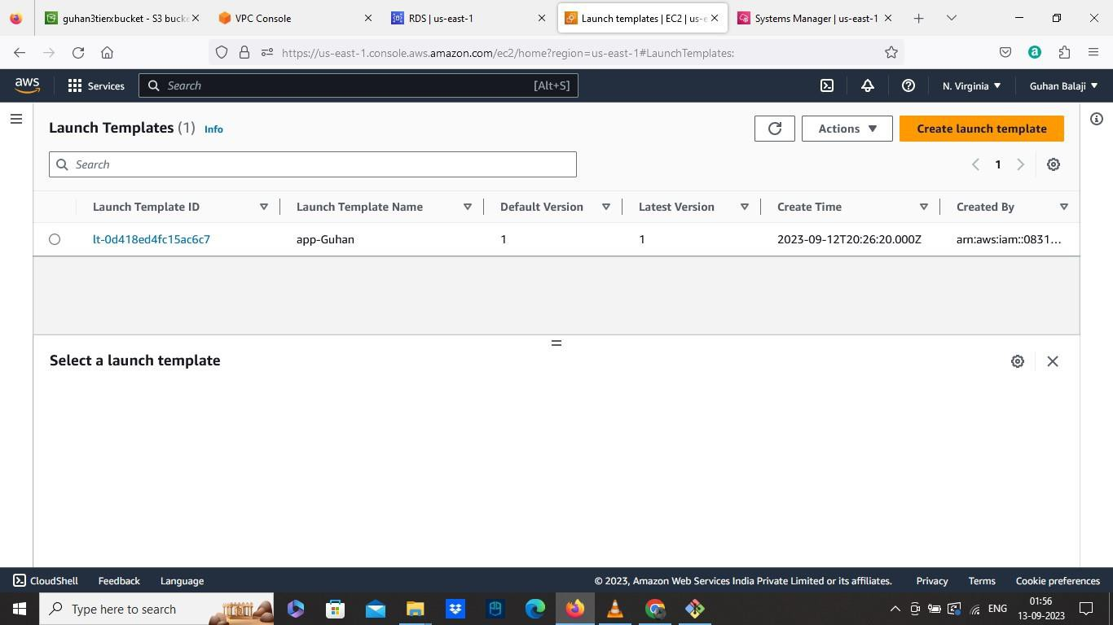

• Create AutoScaling groups

➔ Select the Launch template we created

➔ Select our VPC

➔ Select the two private subnets az1,az2

➔ Select the existing load balancer we created

➔ Select the target groups we created

➔ Set values as 2 in Group Size

➔ Then the ASG will be created.

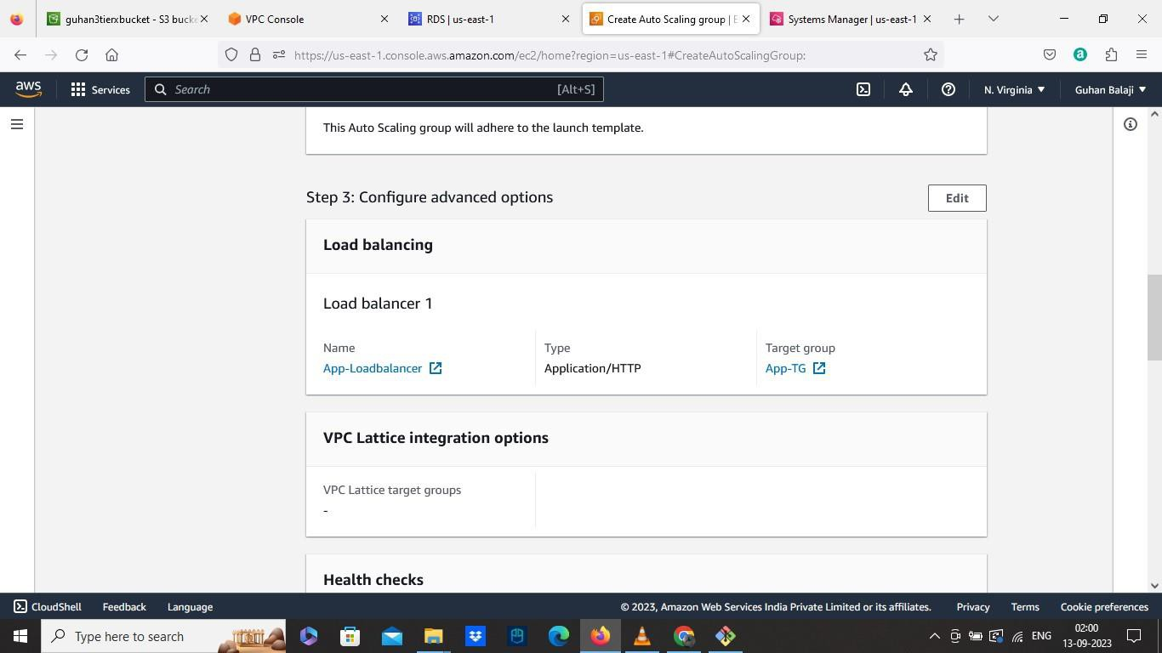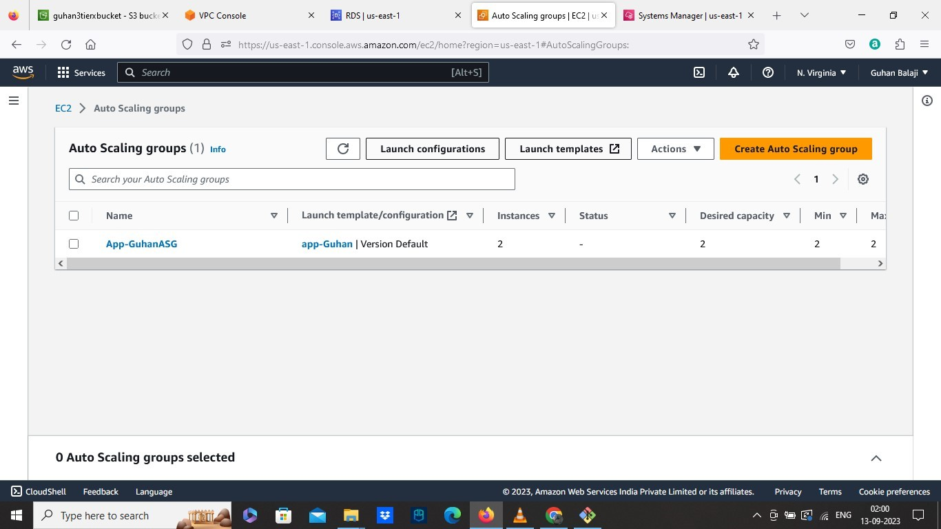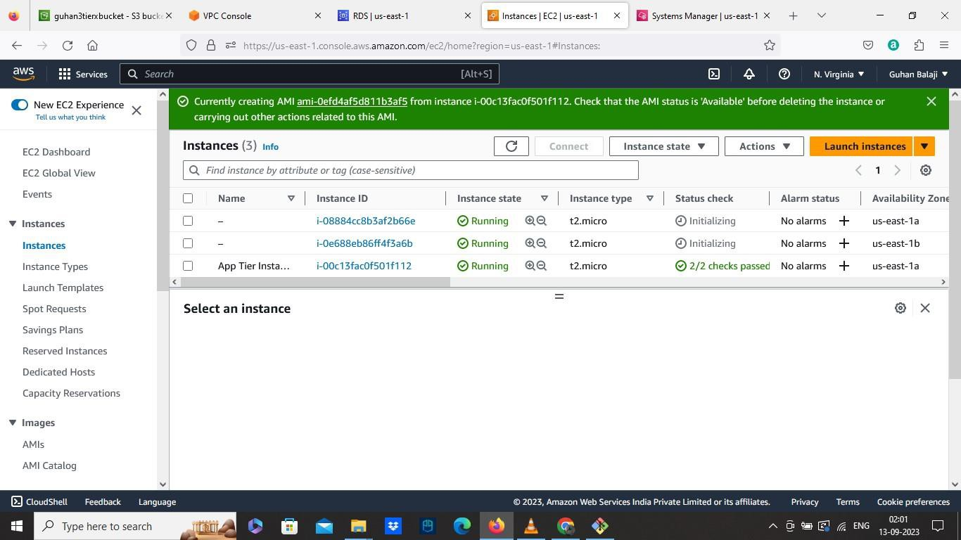

• Now Update the nginx.conf file where we downloaded.

➔ Open the nginx.conf file with notepad++ or can also be edited with gitbash, here iam using notepad++

➔ Scroll down and find the Replace ILB DNS with your Internal Load

balancer DNS and save it

➔ The Modified nginx.conf file is uploaded to our S3 bucket

➔ Also Upload the WEB tier folder to our S3 bucket.

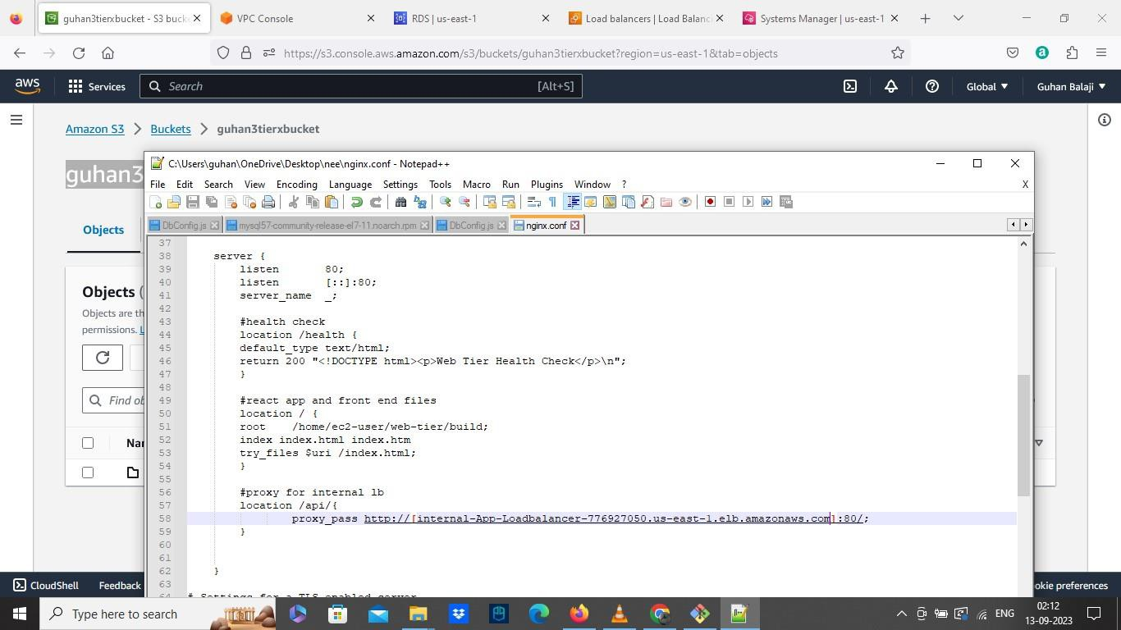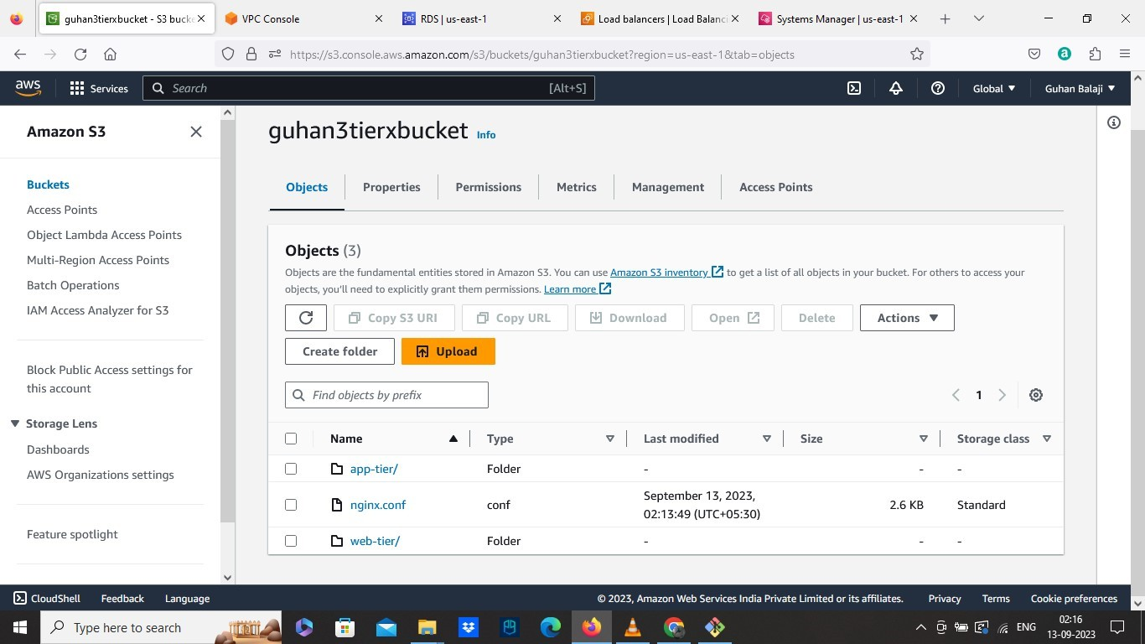

• Now create the WEB instance

➔ Launch an Instance

➔ Select our VPC

➔ Here select the Public web subnet az1 in subnet

➔ Enable the Auto assign the public IP

➔ Select the existing security group which is WEB tier SG

➔ Select our IAM role.

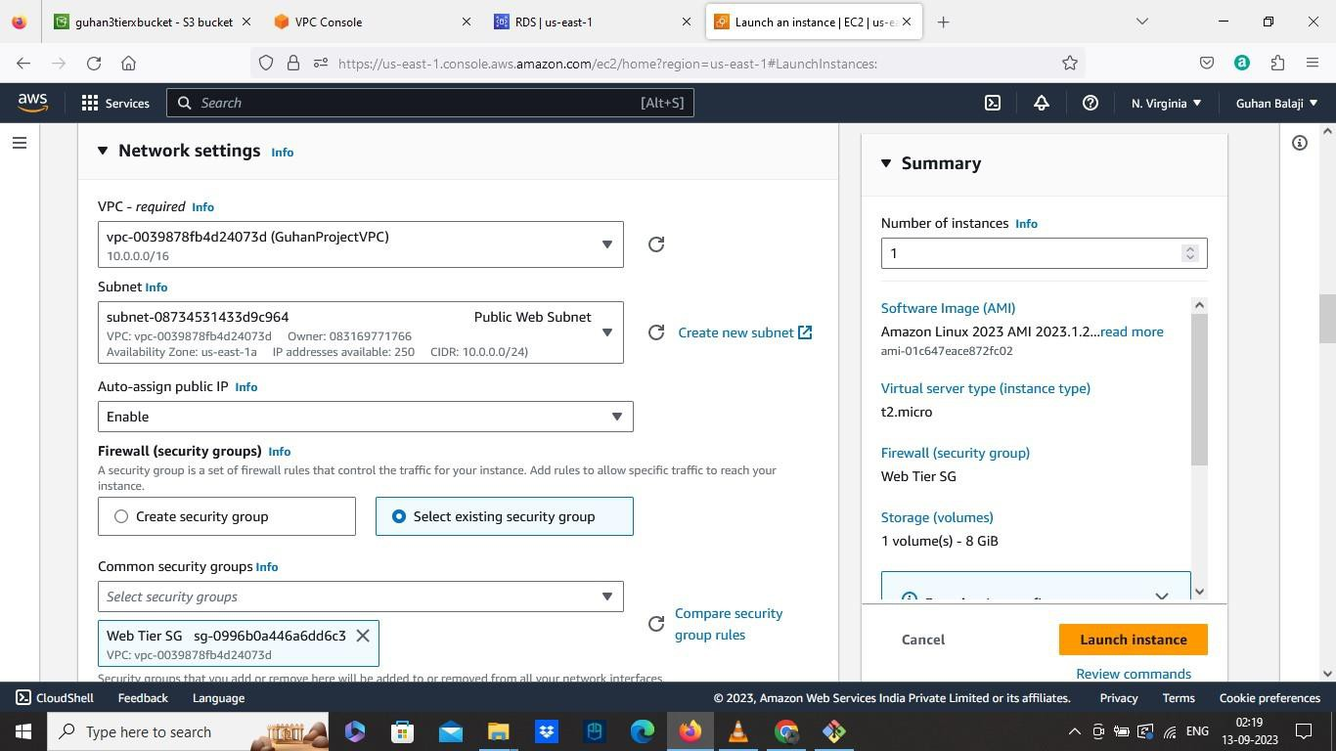

• Connect to the terminal

➔ Run the command sudo -su e c2 -u se r

➔ Ping 8.8.8.8 to check the outside internet connectivity and google DNS

servers

➔ Now we need to install the components for front end, again install NVM

by running these commands: cu rl -o -

h tt p s:// raw.g ithu b u se rcon ten t. co m/n vm -sh /n vm/v0 .3 8 .0 /in sta ll.sh | ba sh

so u rce ~/. ba sh rc

n vm in sta ll 16

n vm u se 1 6

➔ Change the directory cd

➔ Download the codes from our S3 Bucket web tier folder by running this command: a ws s3 cp s3:/ /gu ha n 3tie rxbucke t/ web -tie r/ web -tier –

recu rsive

➔ Create Build folder in Web folder for react app by running this commands: cd we b -tier/

n p m in sta ll

n p m ru n b u ild

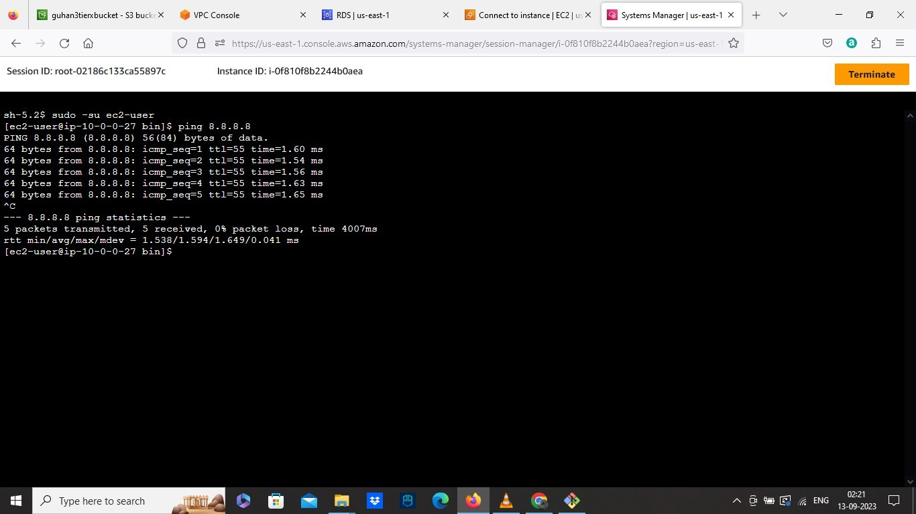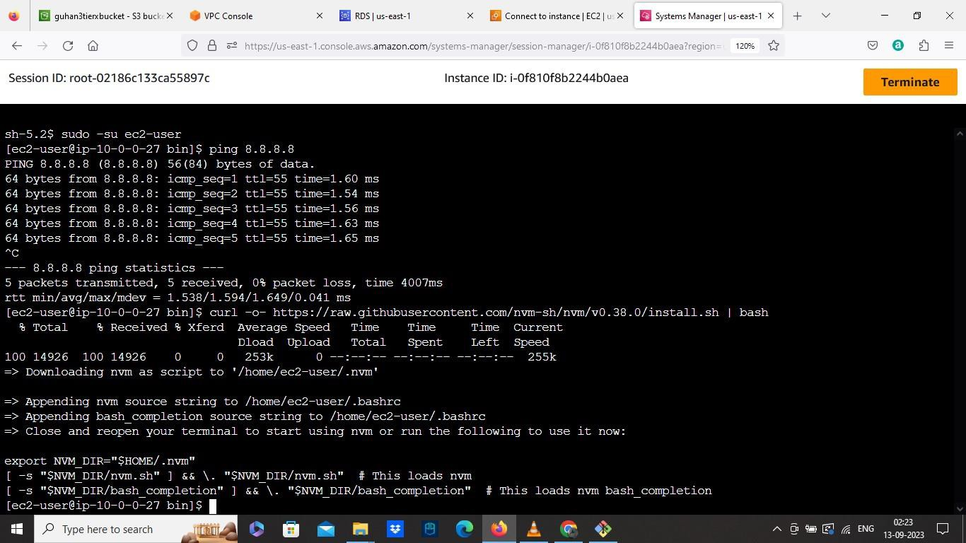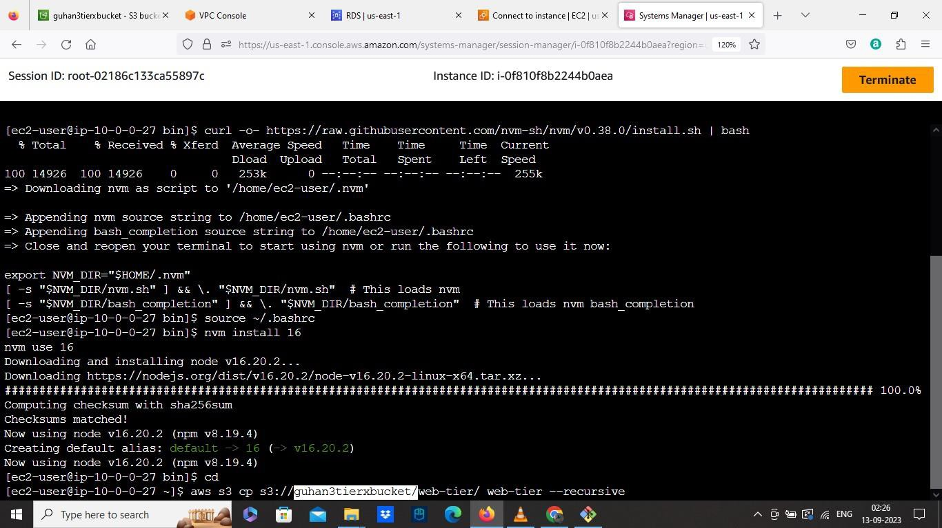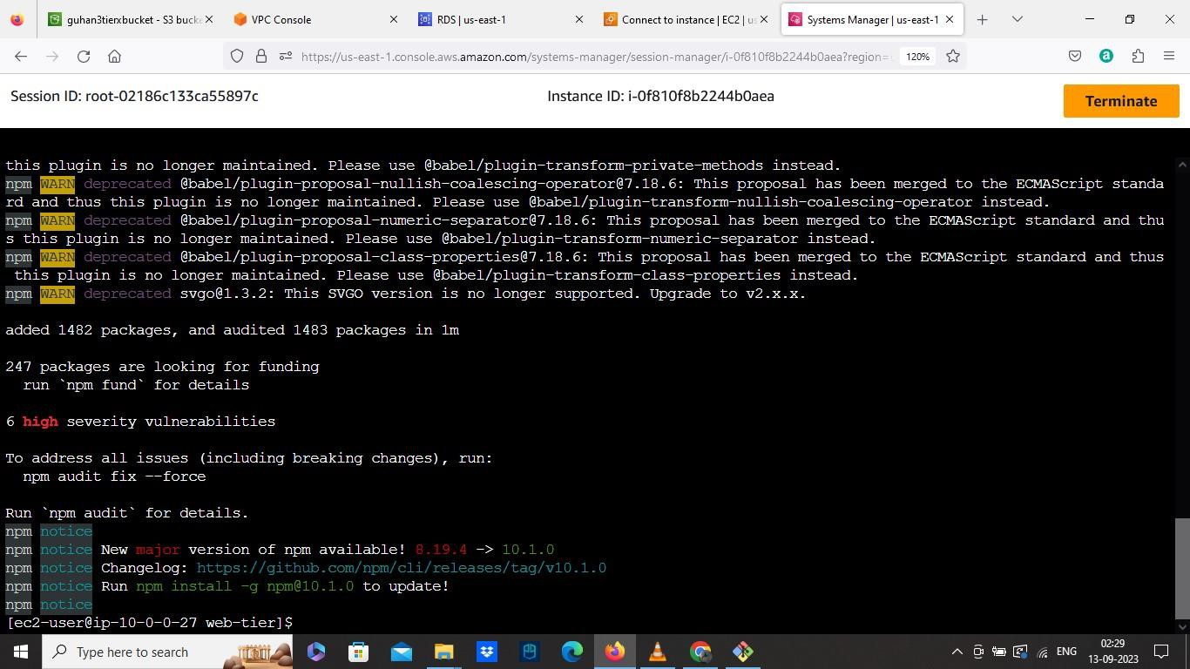

• Install NGINX where this will help to direct our API calls to the internal load balancer.

➔ Run the command: sud o yu m in sta ll ng inx^ c

➔ So now we have to replace the default nginx configuration file from the Nginx we installed with our modified configuration nginx.conf file, where we changed our load balancer DNS name.

➔ Use the command to navigate: cd / e tc/n g inx then list ls and remove the

file from its location by running this command: su d o rm n g inx. co n f

➔ Download the modified from our S3 Bucket using:

su do aws s3 cp s3 :// gu han3 tierx bu cket /ng inx .conf .

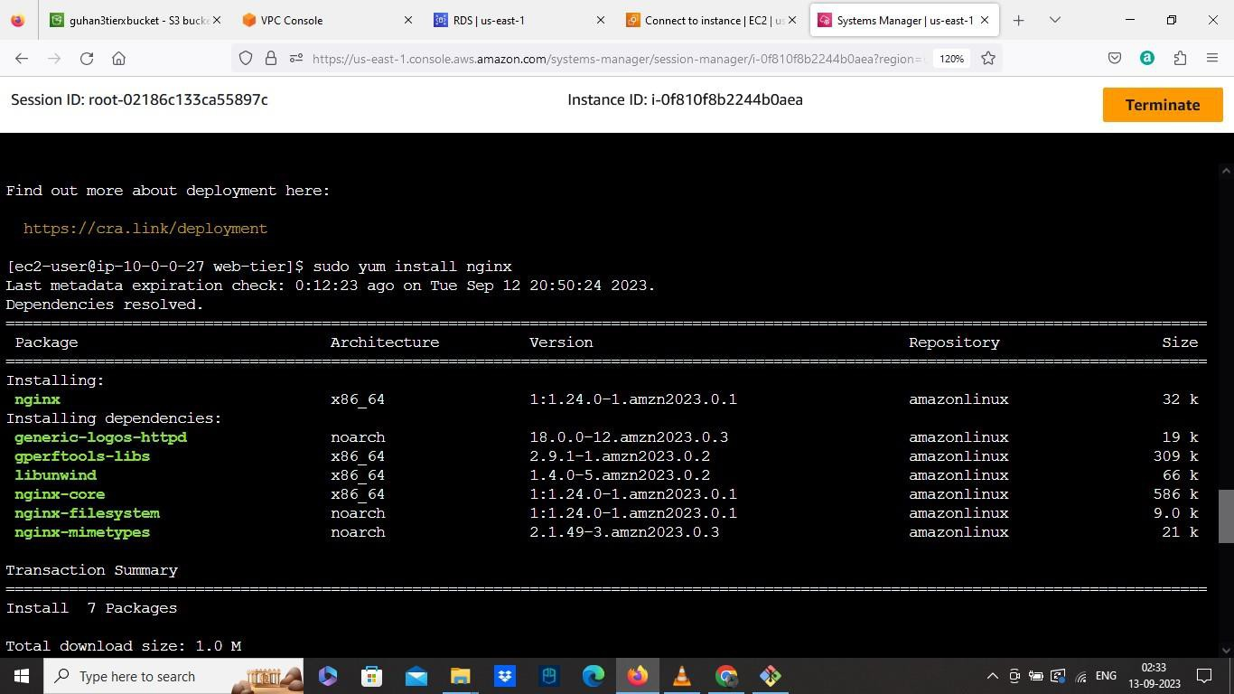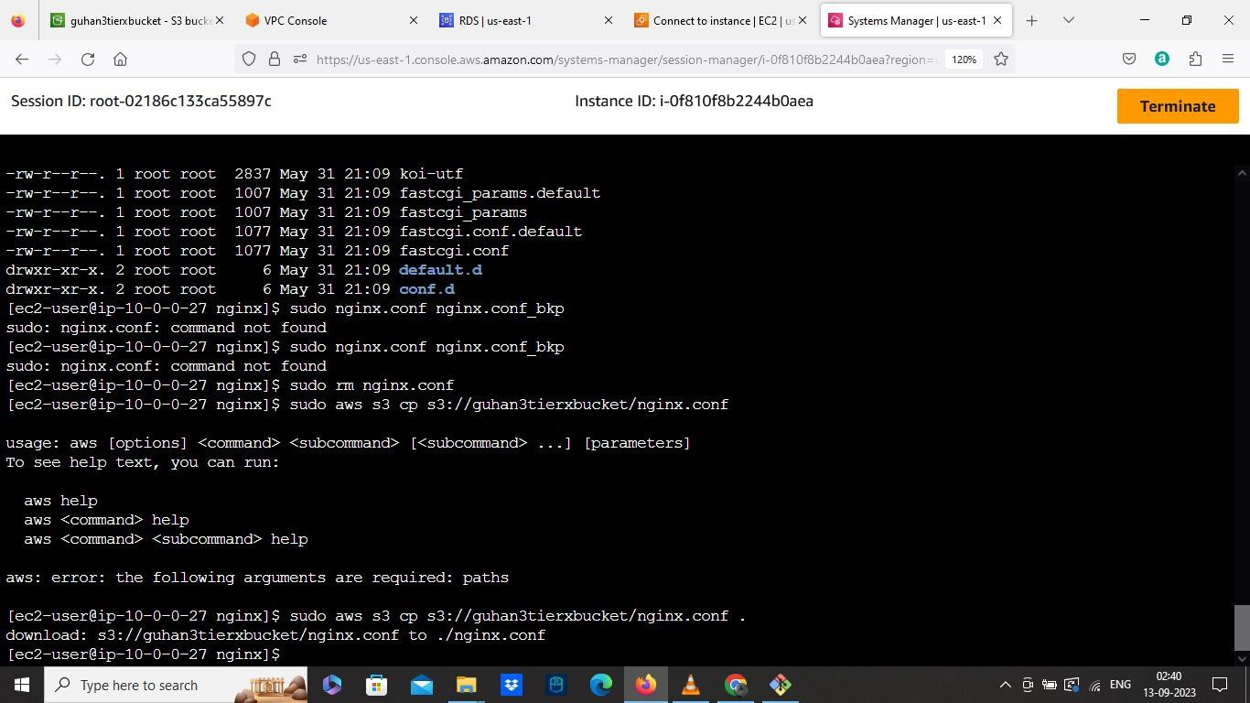

➔ Restart the Nginx by running this command: su d o se rvice ng inx resta rt

➔ Check the status of Nginx with this command: su d o se rvice ng inx

st a tu s

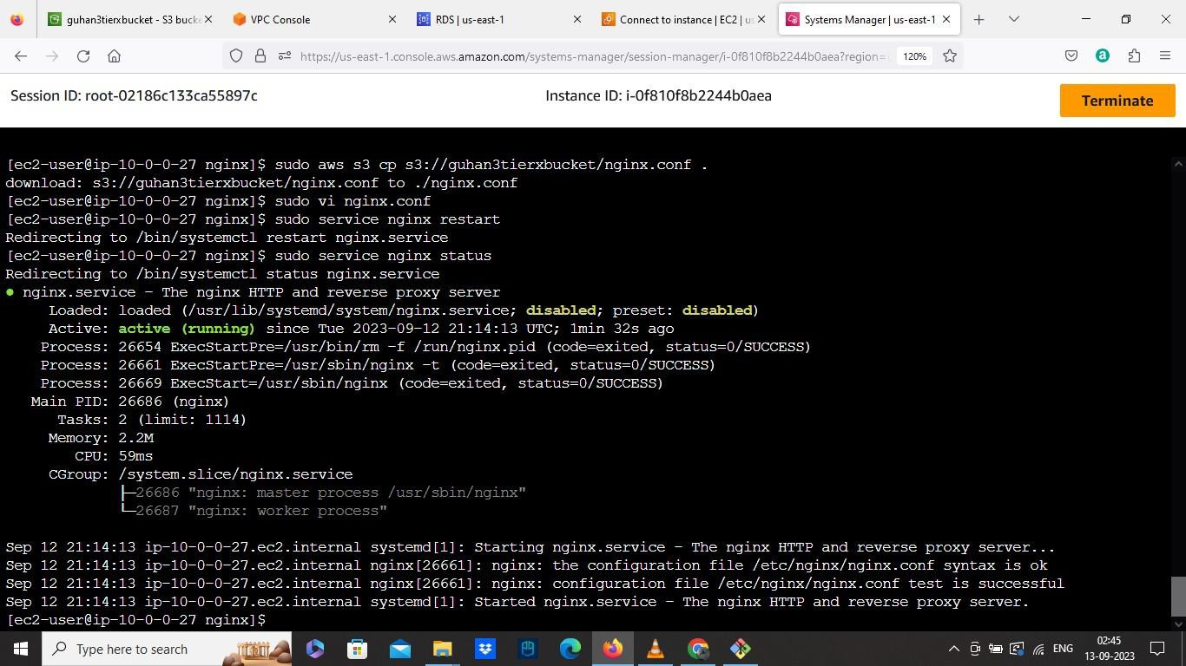

➔ Check whether the Nginx got access by: ch mo d -R 7 55 /h o me /e c2 - user

➔ Maketorunwhenevergetbootrunthiscommand: su do ch kconfig ng inx on

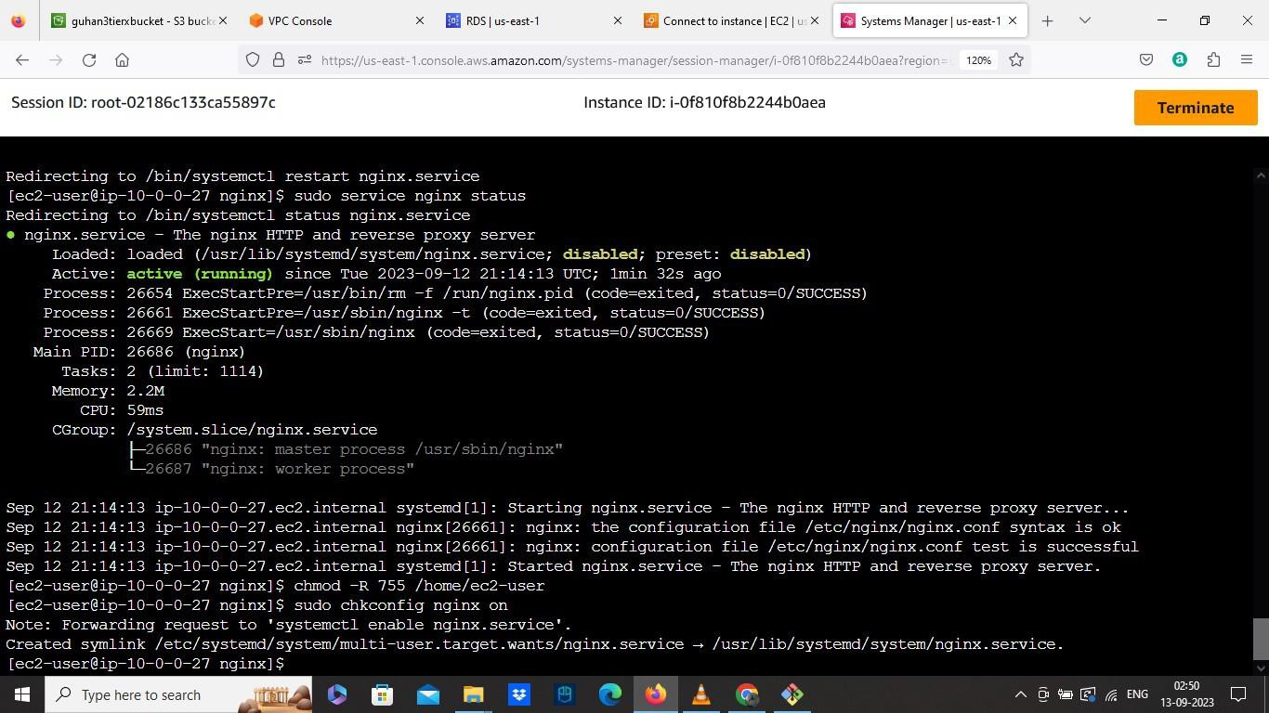

• CreateanImageAMIfromourWEBinstance

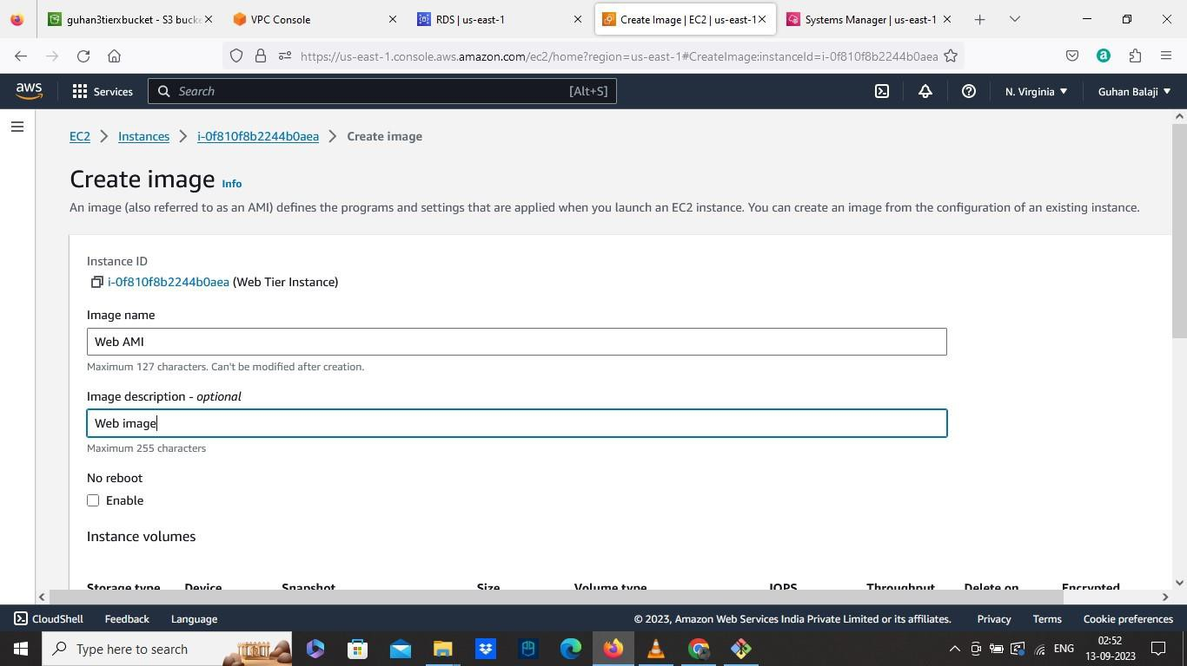

• CreateTargetGroups

➔ SelectThetypeasInstances

➔ GivethenametoourTargetGroup

➔ SelectTheportto80

➔ SelectourcustomVPC

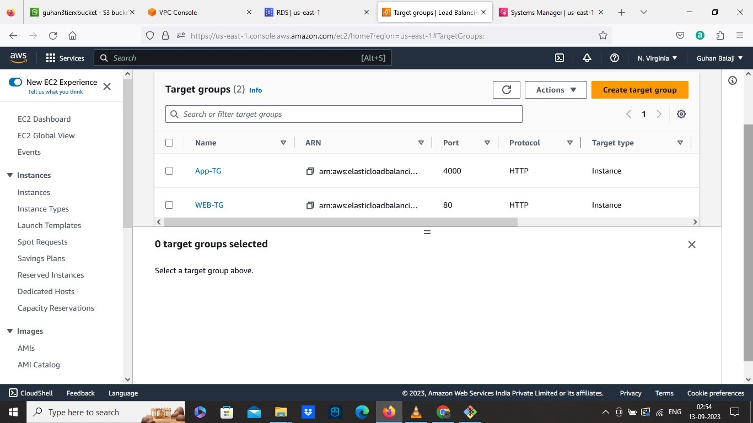

• Create Load balancer

➔ Choose the scheme to Internet Facing

➔ Select our custom VPC

➔ In Mappings Select two public web subnets az1, az2

➔ Select the existing security group which is Internet Facing External

Load balancer

➔ In Listeners and routing select port as 80 and forward to Web Target

Group we created.

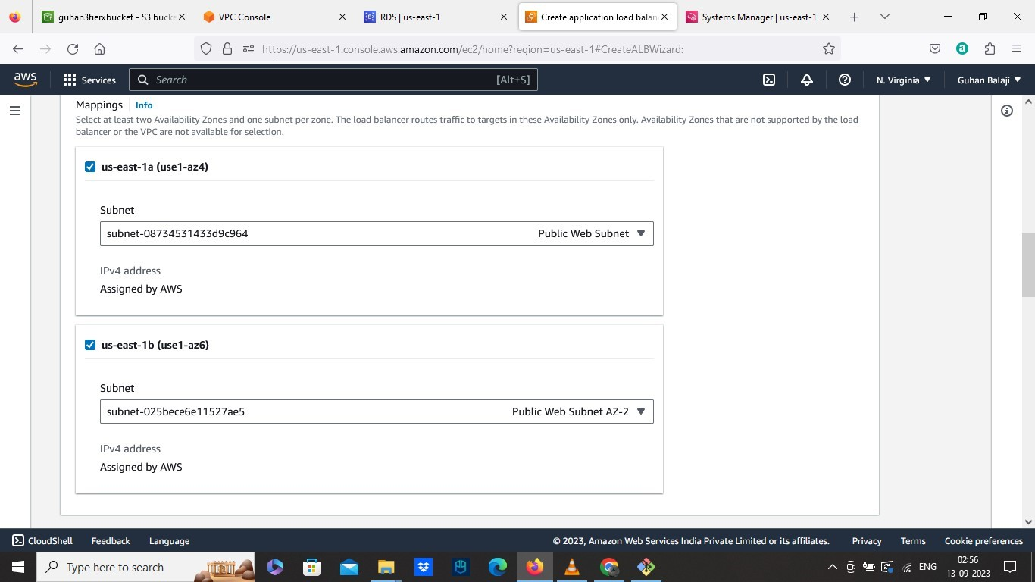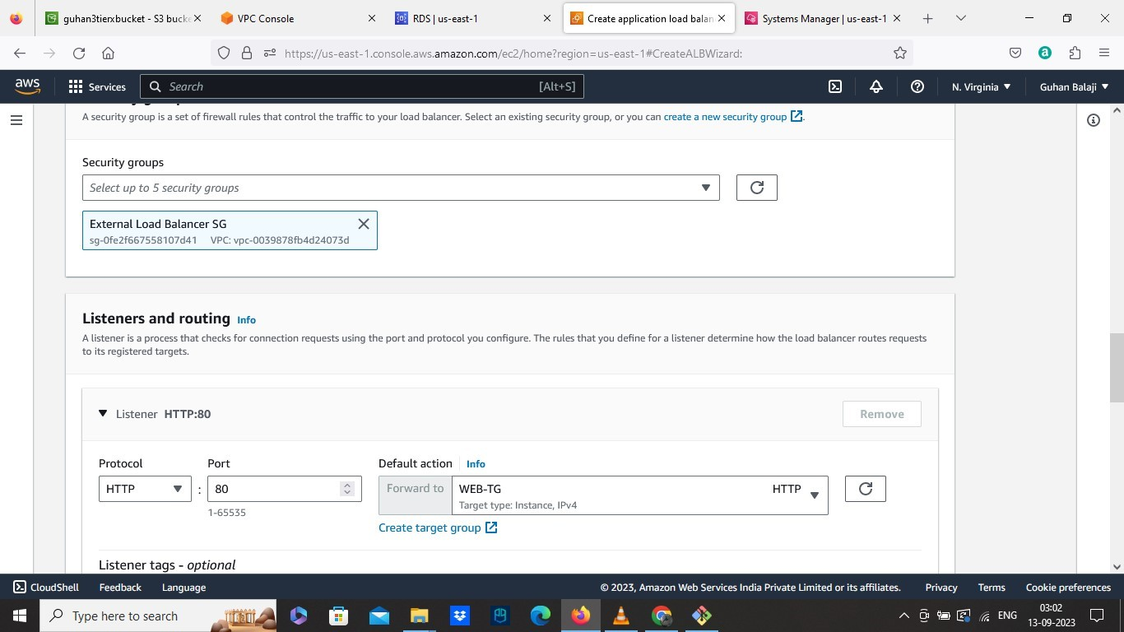

o Create the Launch Template

➔ Select our Web instance AMI from MY AMI

➔ Choose Instance type as free tier

➔ Select the existing security group which is Web tier SG

➔ Select our IAM role

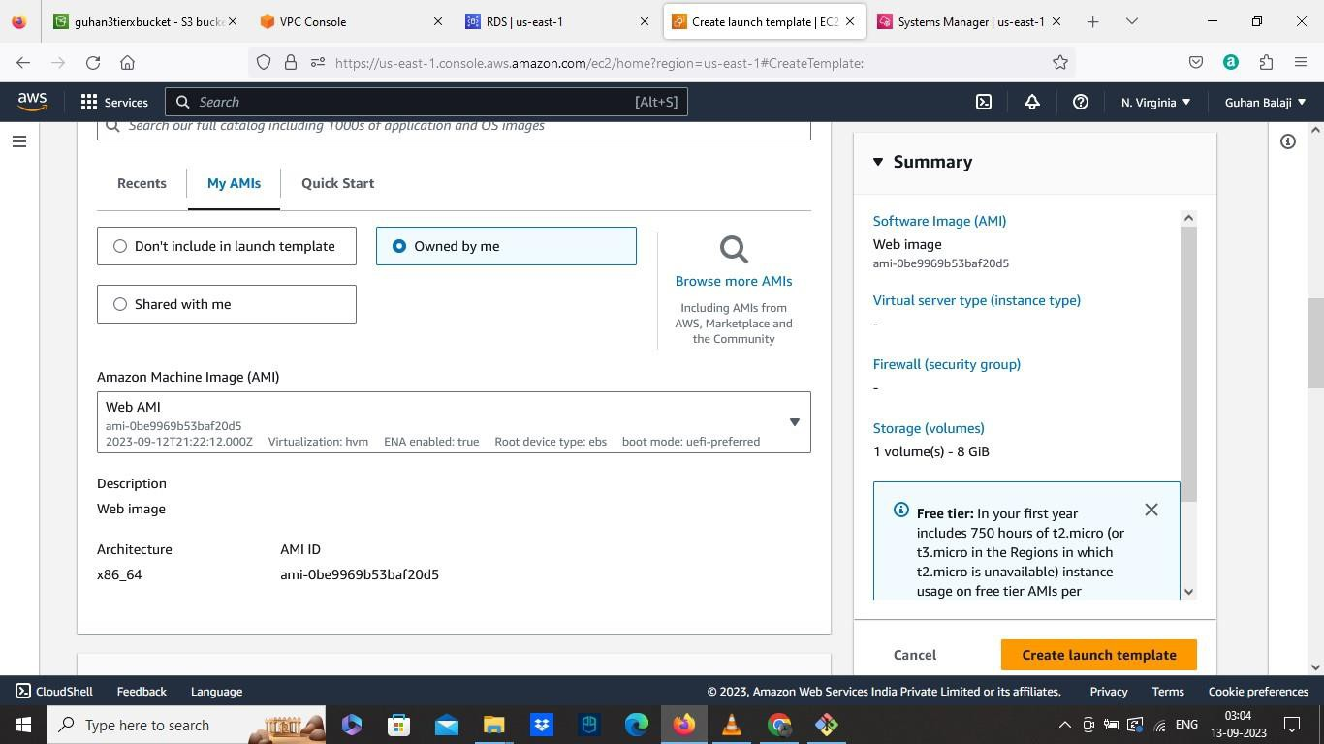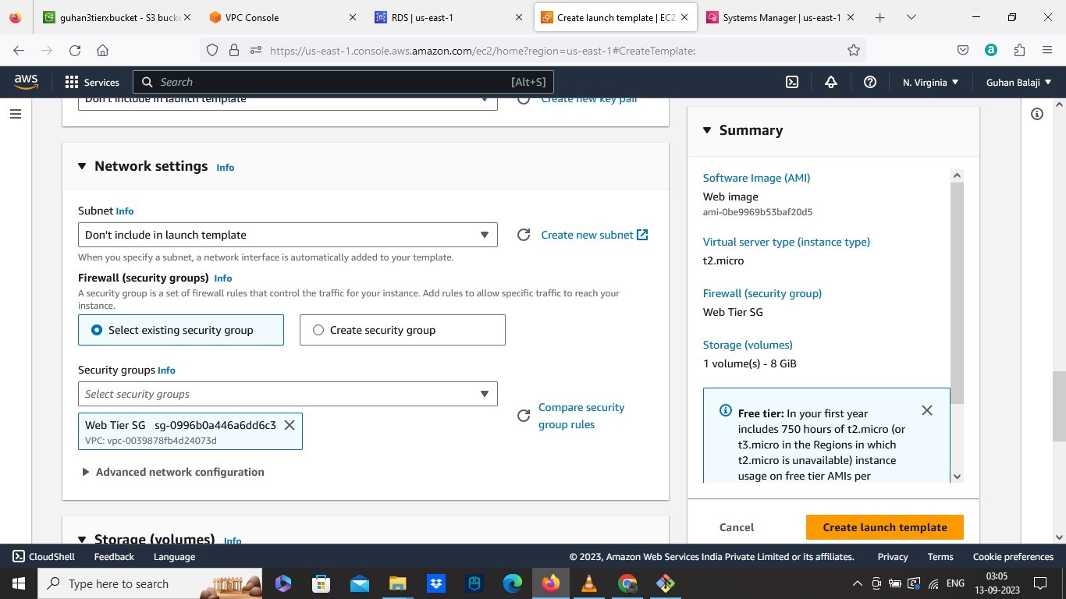

• Create Autoscaling group

➔ Give a name to the ASG

➔ Select our Web Launch Template

➔ Select our Custom VPC

➔ Select the two public web subnets az1,az2

➔ Then attach to existing load balancer we created for WEB

➔ Select the WEB Target group

➔ Change the value to 2 for group size.

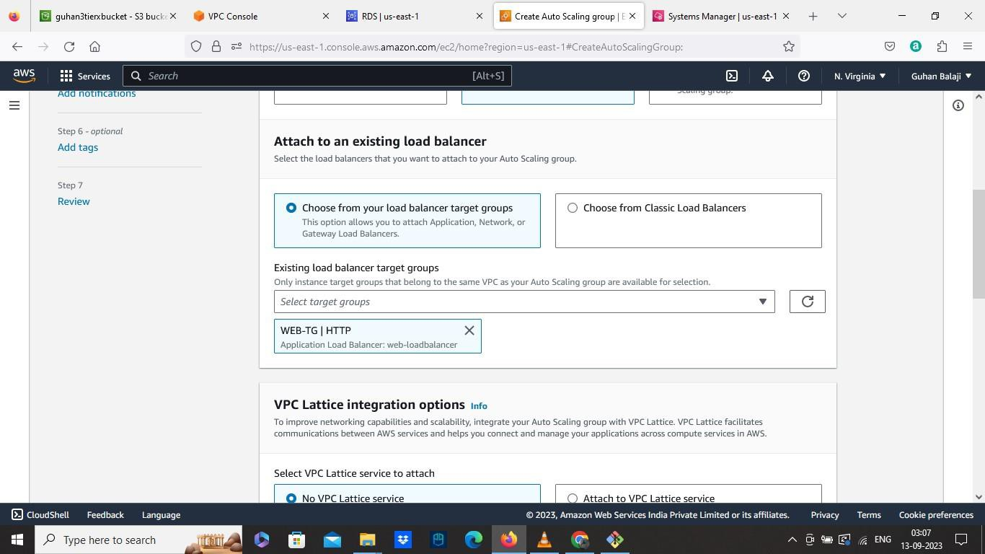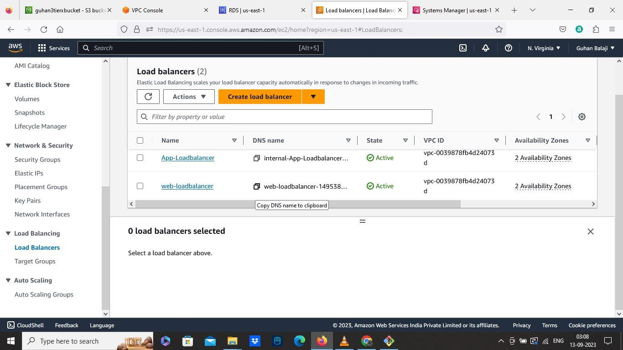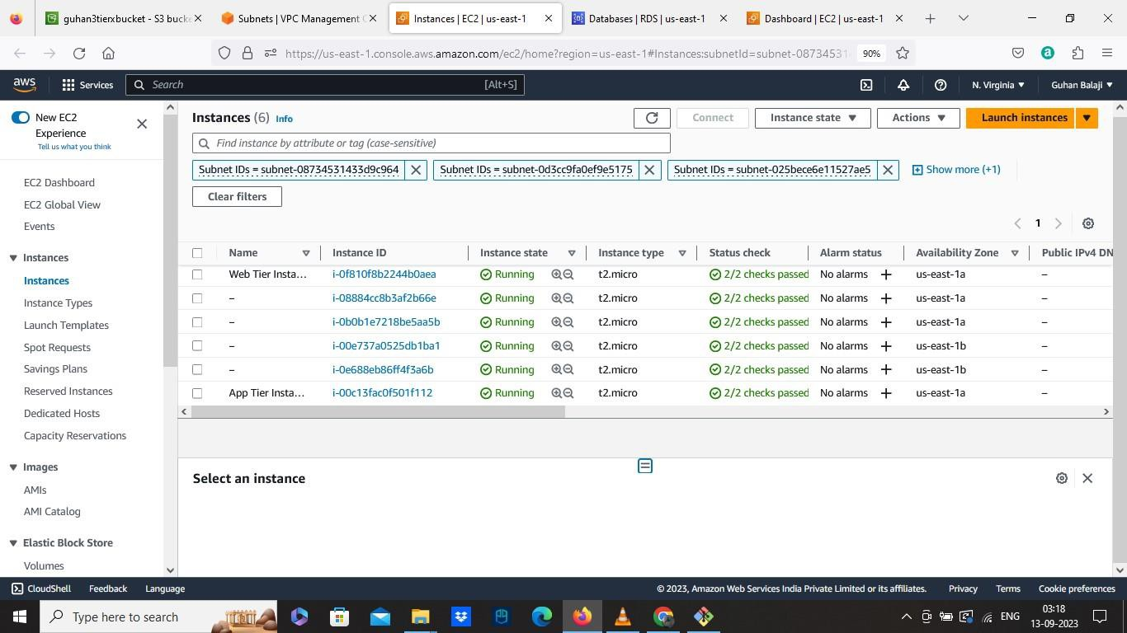

• Now Launch the website by copying the DNS name of WEB load balancer and paste into the browser

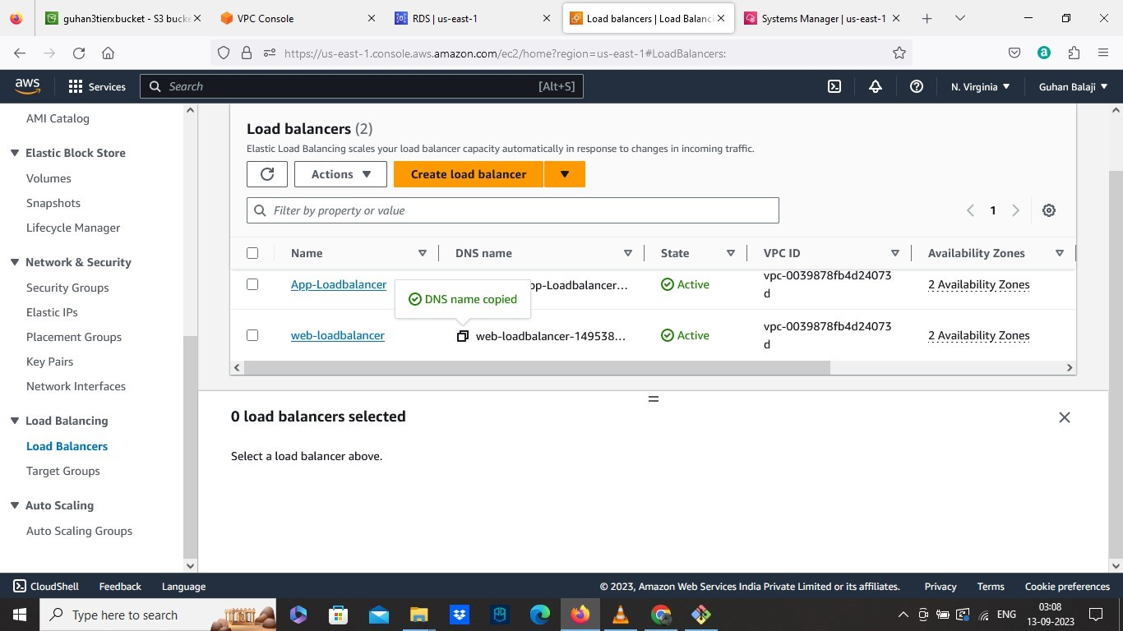

• OUTP UT:

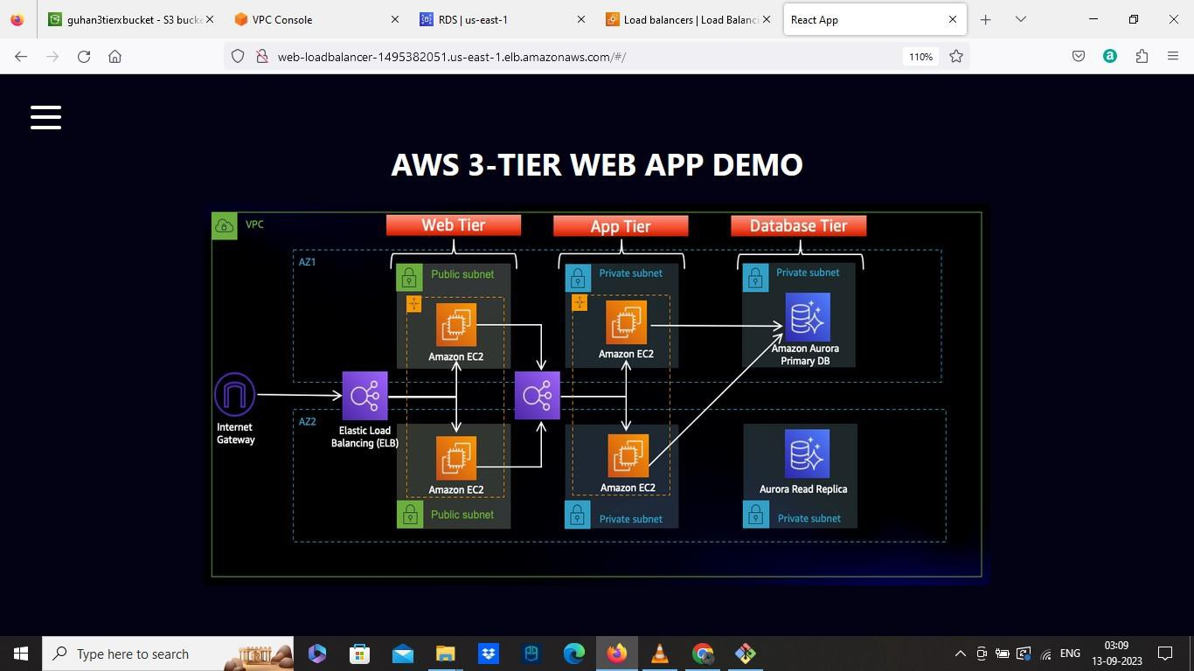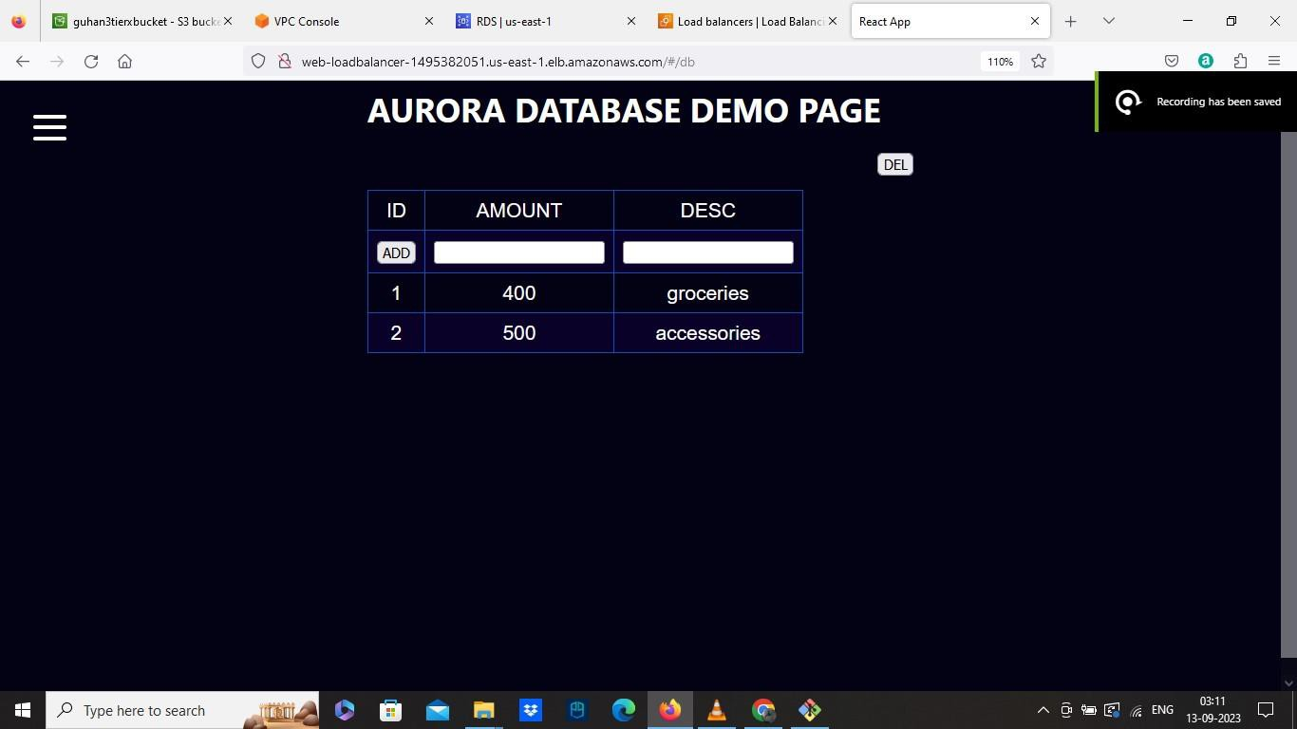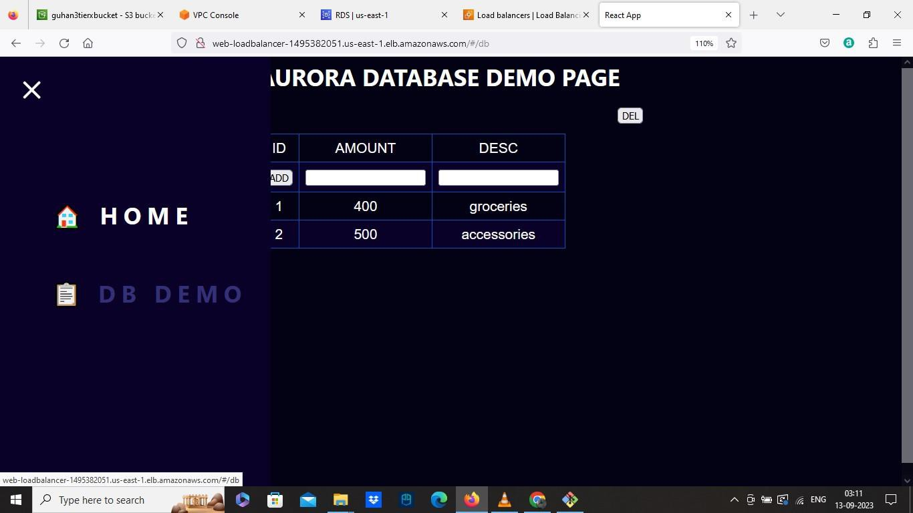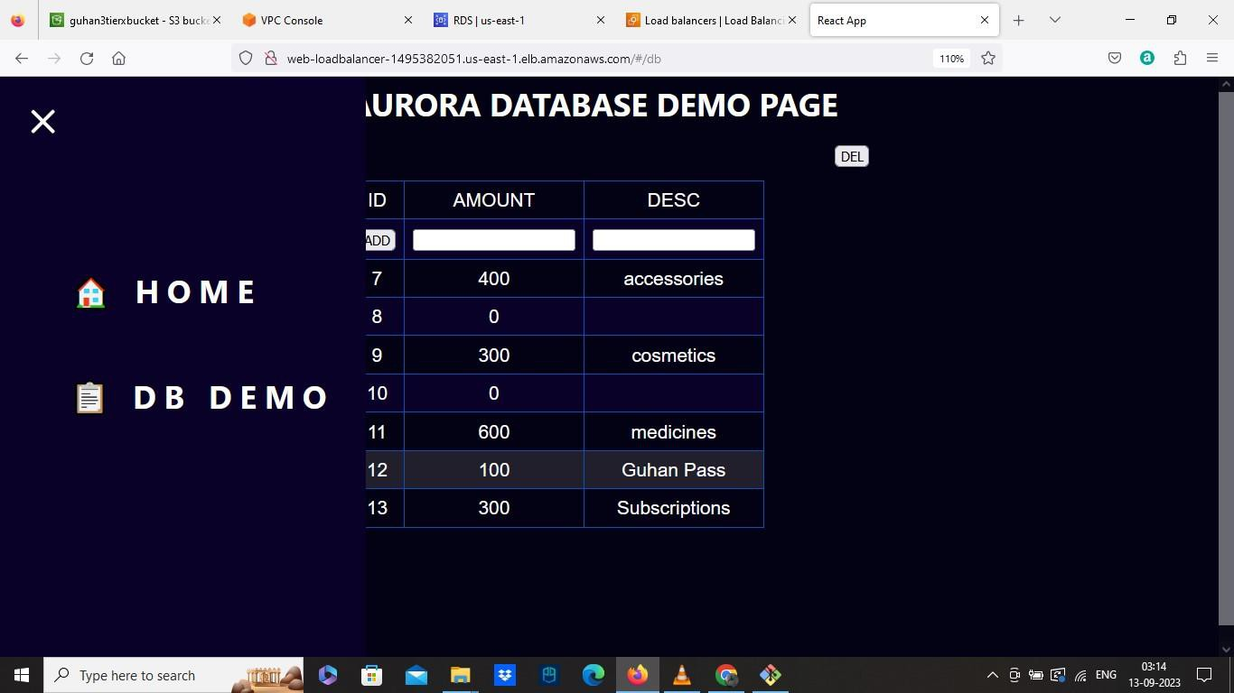

A RCHITECTURE OF THE P ROJE CT:

Internet Gateway

N.Virginia

EXTERNAL

LB

PUBLIC SUBNET AZ1 PUBLIC SUBNET AZ2

VPC

EC2 EC2

PRIVATE SUBNET AZ1

EC2

INTERNAL

LB

PRIVATE SUBNET AZ2

EC2

AURORA PRIMARY

DB

AURORA READ REPLICA



PRIVATE SUBNET AZ1 PRIVATE SUBNET AZ2

US EAST AZ1 US EAST AZ2